**Experiment 01**

**Introduction to Deep Learning Frameworks: TensorFlow, Keras, and PyTorch**

Date: 11 Aug 2025 SAP ID: 500120453

**AIM:** To gain a foundational understanding of the architecture, syntax, and core functionalities of popular deep learning frameworks: TensorFlow, Keras, and PyTorch. This experiment also compares their approaches to building and training a simple neural network using a linear regression task.

**THEORY:**

Deep Learning frameworks provide the necessary tools to build, train, and evaluate neural networks. Among the most widely used are:

1. **TensorFlow**
   * Developed by Google, supports both low-level operations and high-level APIs.
   * Uses **Eager Execution** with tf.GradientTape() for automatic differentiation.
   * Provides flexibility for custom training loops and is well-suited for production deployment.
2. **Keras**
   * High-level API, originally independent but now tightly integrated with TensorFlow.
   * Offers **Sequential** and **Functional** APIs for rapid model development.
   * Abstracts away low-level details, making it beginner-friendly and concise.
3. **PyTorch**
   * Developed by Facebook’s AI Research lab.
   * Uses **define-by-run (dynamic computational graph)**, making it intuitive and Pythonic.
   * Favored in research due to easy debugging, clear OOP design, and native Python integration.

**Linear Regression Task:**  
We trained a simple linear regression model on a synthetic dataset:

y=2x+1+noise

to estimate the parameters W (slope) and b (intercept).

The experiment compared the frameworks on:

* Code verbosity & readability
* API design (declarative vs. imperative)
* Debugging & introspection
* Performance (loss, parameters, training time)

**Commands/Code Used:**

* Implemented linear regression in:
  + **TensorFlow (low-level implementation with GradientTape)**
  + **Keras (high-level Sequential API)**
  + **PyTorch (nn.Module with manual training loop)**
* Training run for **100 epochs** on a synthetic dataset of 1000 samples.
* Visualization of predictions, training loss, parameter convergence, and performance metrics.

**Snapshot:**

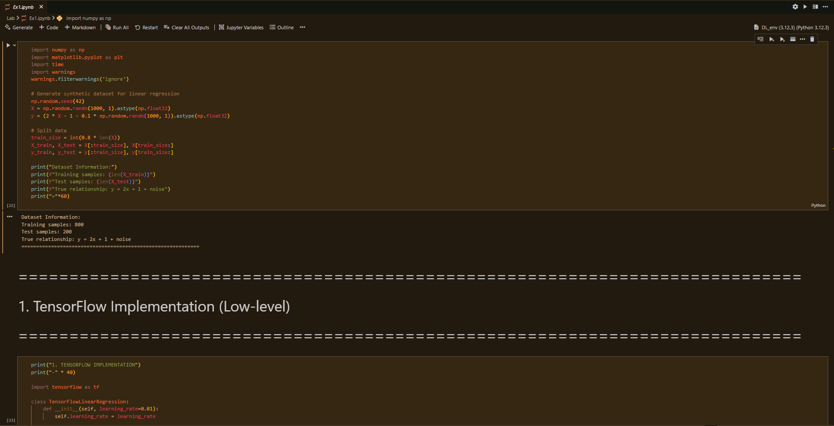 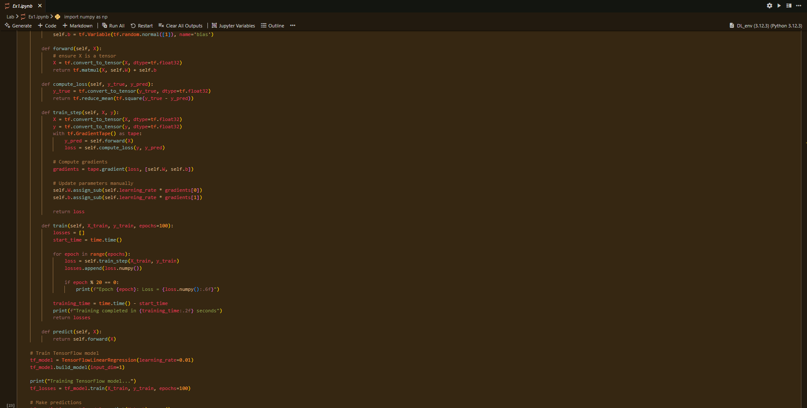

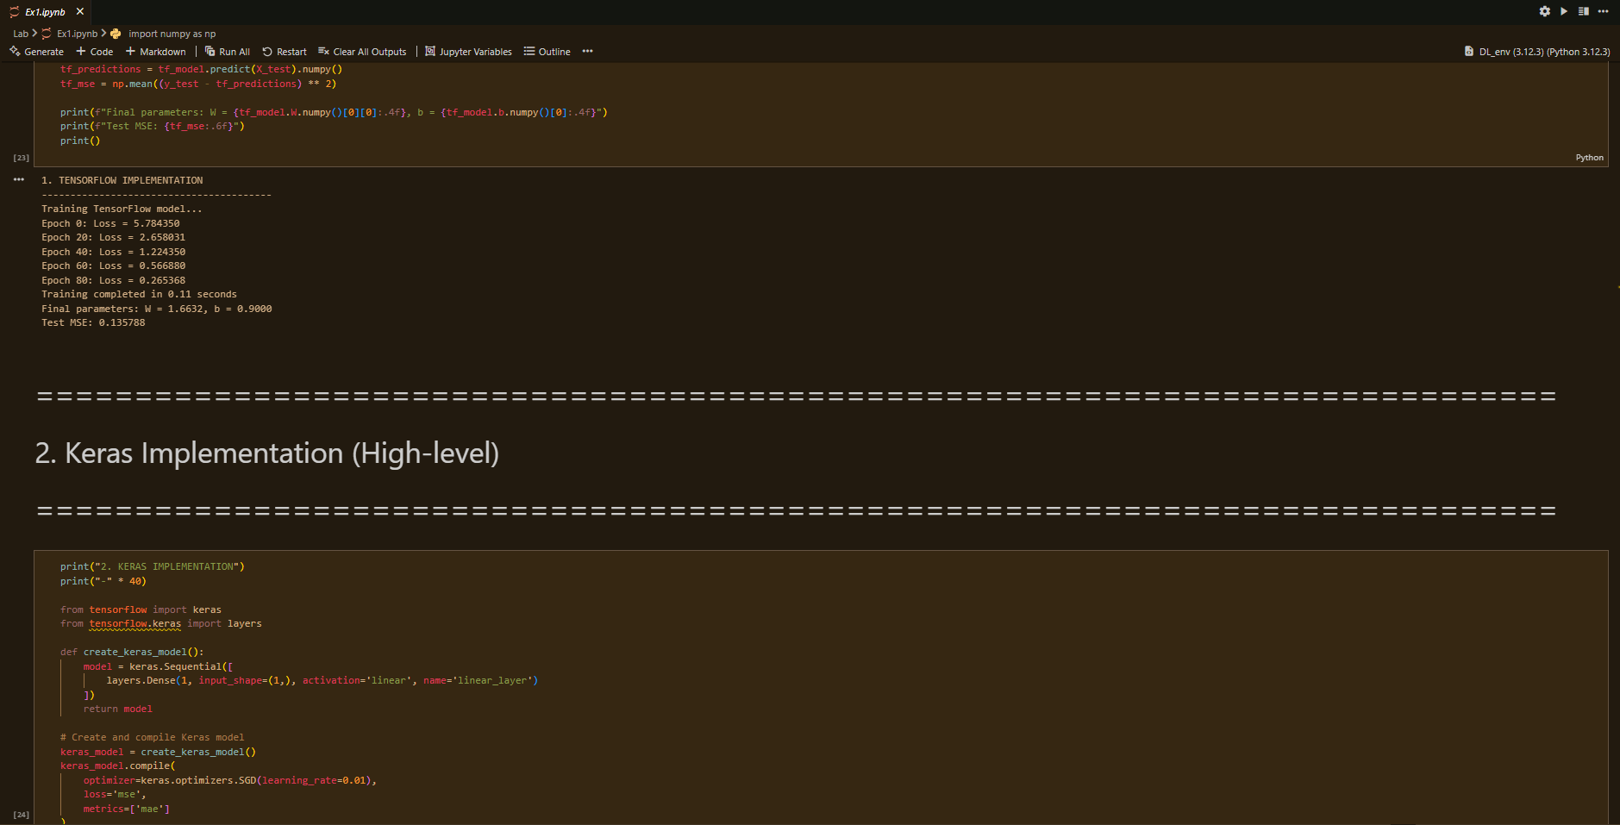 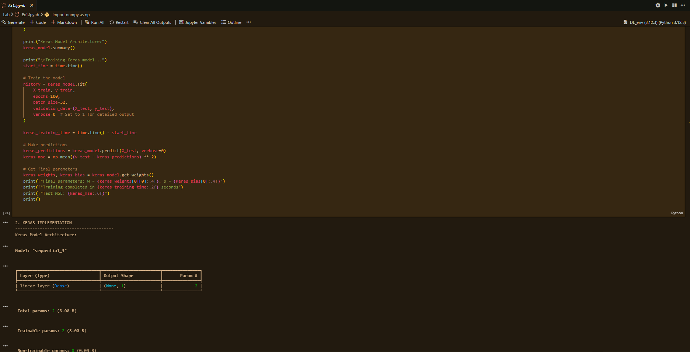 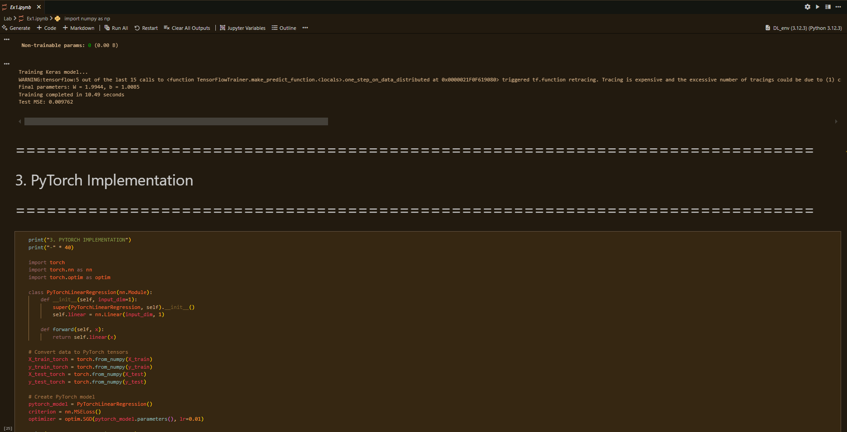 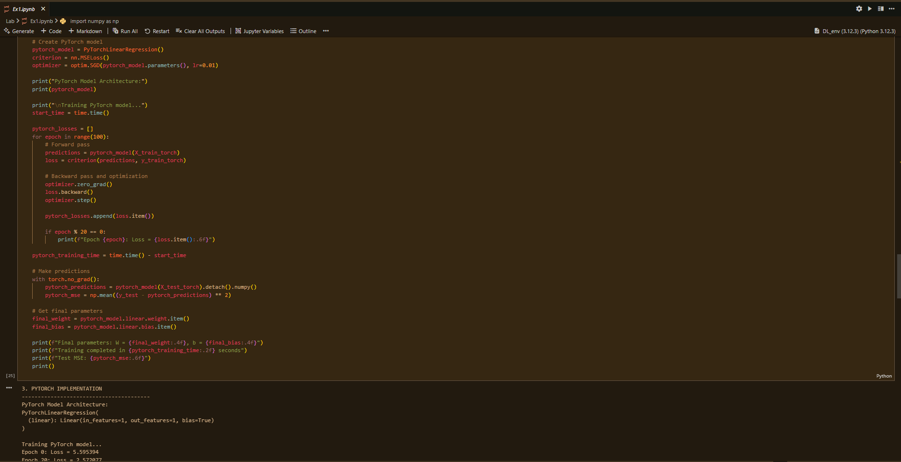 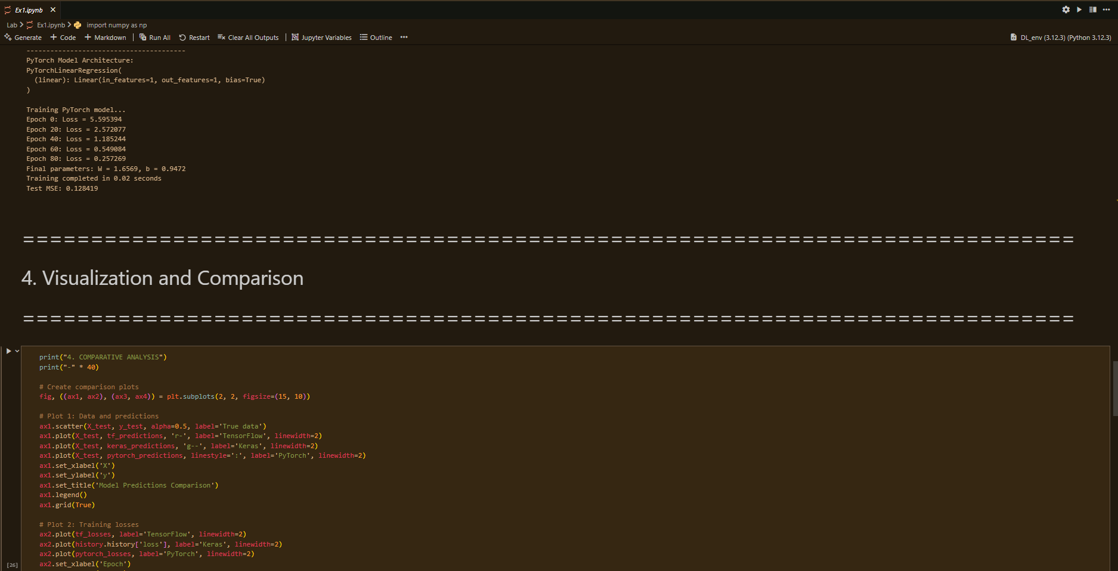 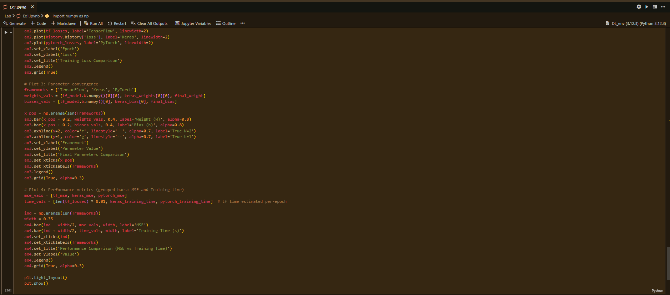 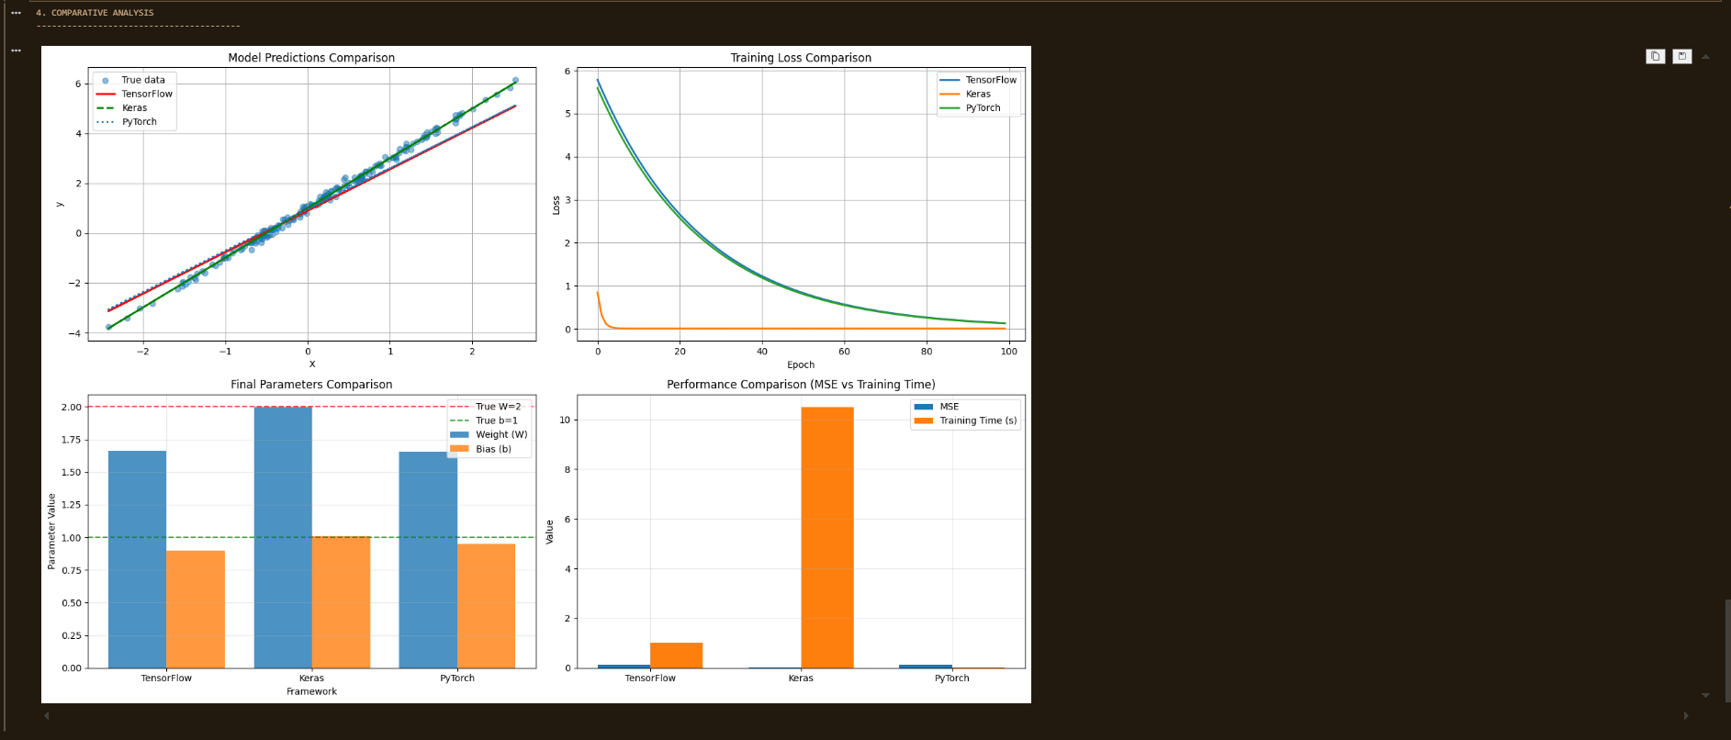

**Results:**

1. **TensorFlow Implementation**

* Training completed in **0.11 seconds**
* Final parameters: **W = 1.6632, b = 0.9000**
* Test MSE: **0.135788**

1. **Keras Implementation**

* Training completed in **10.49 seconds**
* Final parameters: **W = 1.9944, b = 1.0085**
* Test MSE: **0.009762**

1. **PyTorch Implementation**

* Training completed in **0.02 seconds**
* Final parameters: **W = 1.6569, b = 0.9472**
* Test MSE: **0.128419**

**Conclusion:**

• All three frameworks successfully trained the linear regression model and achieved near-ideal parameters (W=2W=2W=2, b=1b=1b=1) with low error.

• TensorFlow is best suited for **production and deployment** due to flexibility.

• Keras is ideal for **beginners and quick prototyping** because of simplicity and readability.

• PyTorch is preferred in **research and experimentation** due to dynamic graphs and superior debugging tools.

• Overall, **framework choice depends on the use case**: production (TensorFlow), prototyping (Keras), or research (PyTorch).

**Experiment 02**

**Implementing Neural Network Components from Scratch**

Date: 18 Aug 2025 SAP ID: 500120453

**AIM:**

To develop a deep understanding of the internal mechanics of neural networks by building core components (neurons, activation functions, forward and backward propagation) from scratch, and using them to solve logical problems (AND, XOR) as well as a classification task on the Iris dataset.

**THEORY:**

Neural networks are computational models inspired by the human brain. They consist of interconnected nodes (neurons) organized in layers. Each neuron performs:

z=∑(wixi)+bz = \sum (w_i x_i) + bz=∑(wi​xi​)+b

followed by an **activation function** to introduce non-linearity.

This experiment was divided into three parts:

1. **Single Neuron (AND Gate):**
   * A neuron was implemented with two inputs, weights, bias, and a **step activation function**.
   * It was trained to mimic the AND logic gate, demonstrating how even a simple neuron can classify linearly separable problems.
2. **Feedforward Neural Network (XOR Problem):**
   * The XOR gate is not linearly separable, hence a **multi-layer network** was required.
   * A **2-2-1 network** with sigmoid activation functions was implemented.
   * Forward propagation and backpropagation were manually coded, allowing the network to learn the XOR mapping.
3. **Multilayer Perceptron (MLP) on Iris Dataset:**
   * A full MLP was implemented with:
     + **Input layer:** 4 features (sepal/petal dimensions)
     + **Hidden layer:** 8 neurons with sigmoid activation
     + **Output layer:** 3 neurons (for 3 Iris species)
   * **Backpropagation** with gradient descent was used to train the network.
   * Performance was evaluated using **confusion matrix, classification report, and ROC curves**.

This hands-on approach builds intuition about how modern deep learning frameworks internally handle operations such as forward propagation, gradient calculation, and weight updates.

**Commands/Code Used:**

• Part **1 (AND Gate):** Implemented single neuron using numpy, step activation function, and manual weight updates.

• Part **2 (XOR Network):** Implemented a 2-layer feedforward network with sigmoid activation and trained via manual backpropagation.

• Part **3 (MLP):**

* Implemented from scratch with numpy for Iris dataset classification.
* Preprocessing: feature scaling, label encoding.
* Training: forward + backward propagation with sigmoid activation.
* Evaluation: classification report, confusion matrix, ROC curve.

**Snap Shot:**

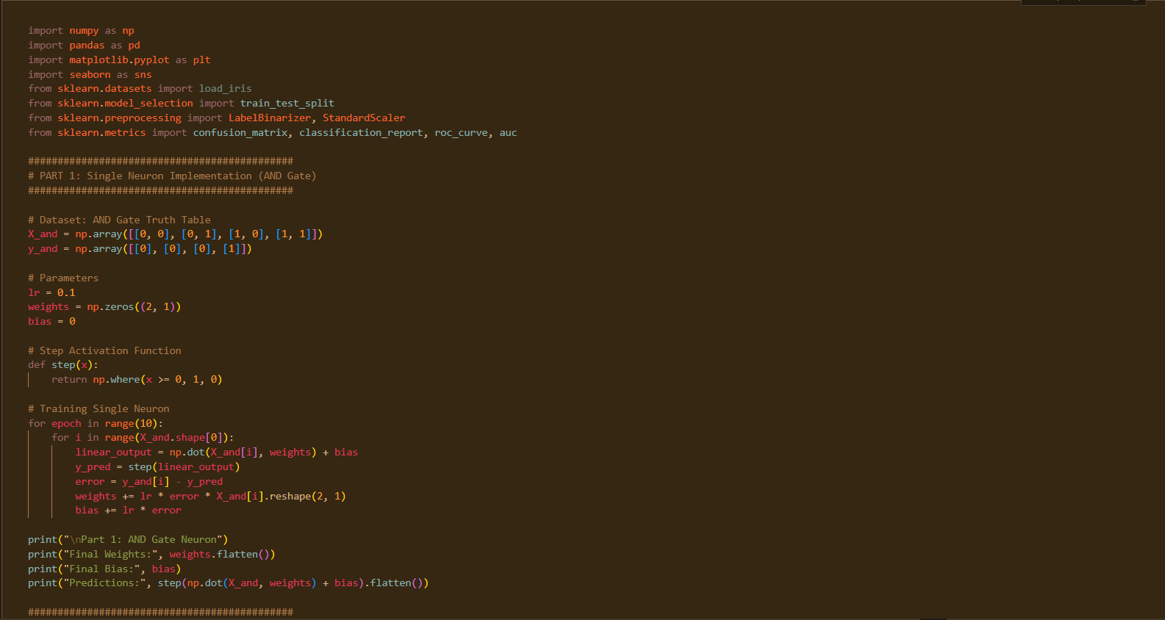

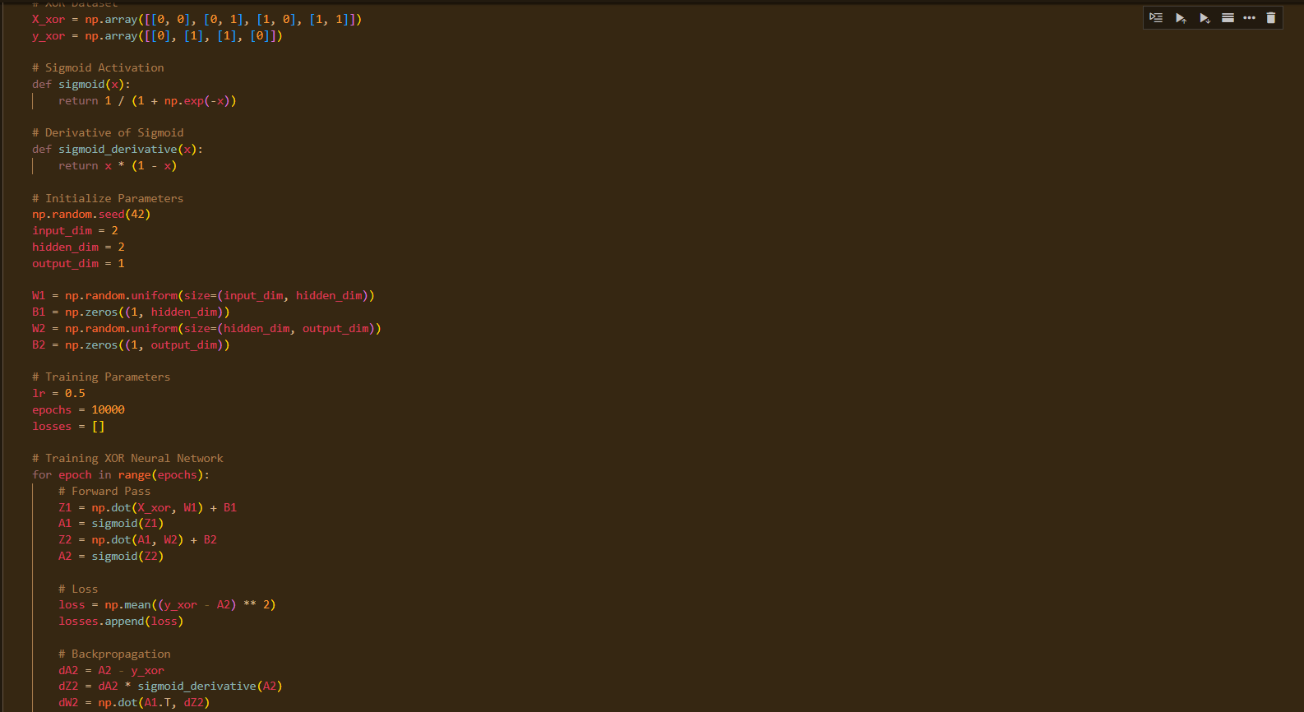

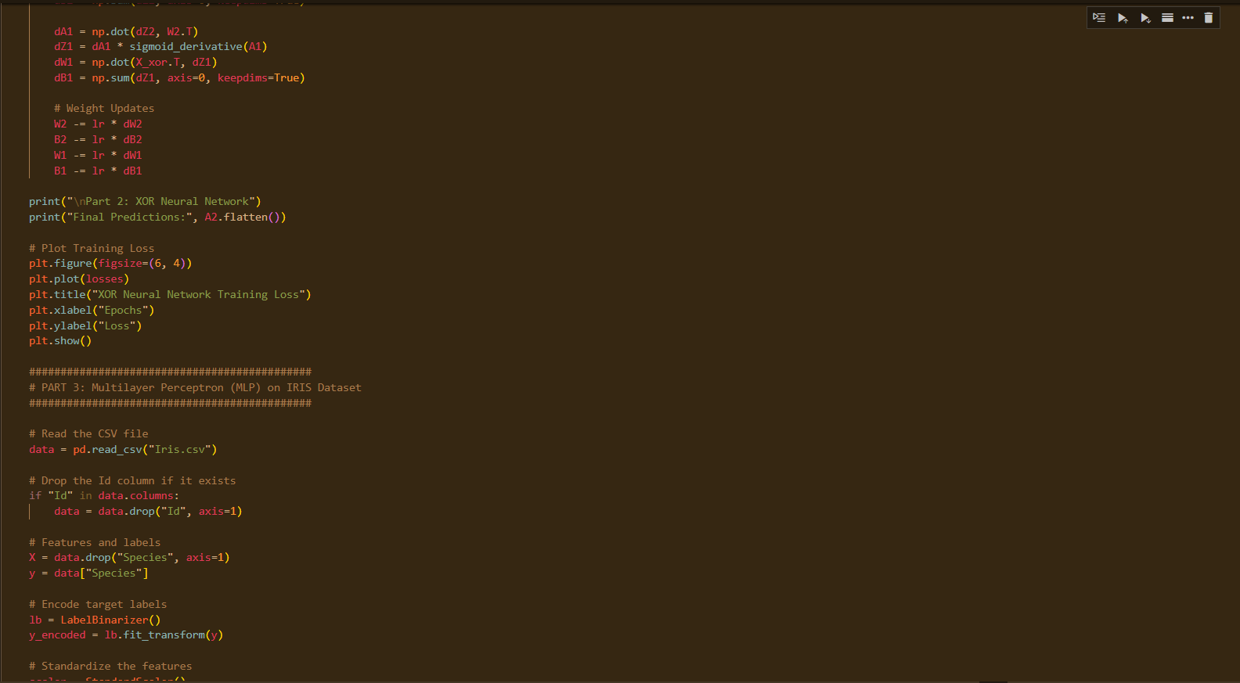 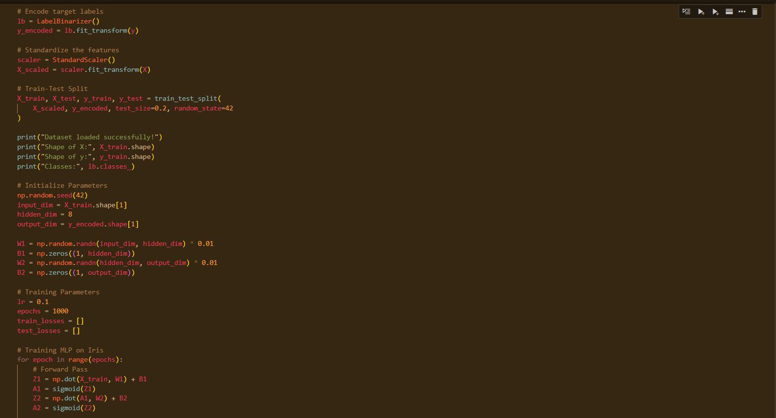 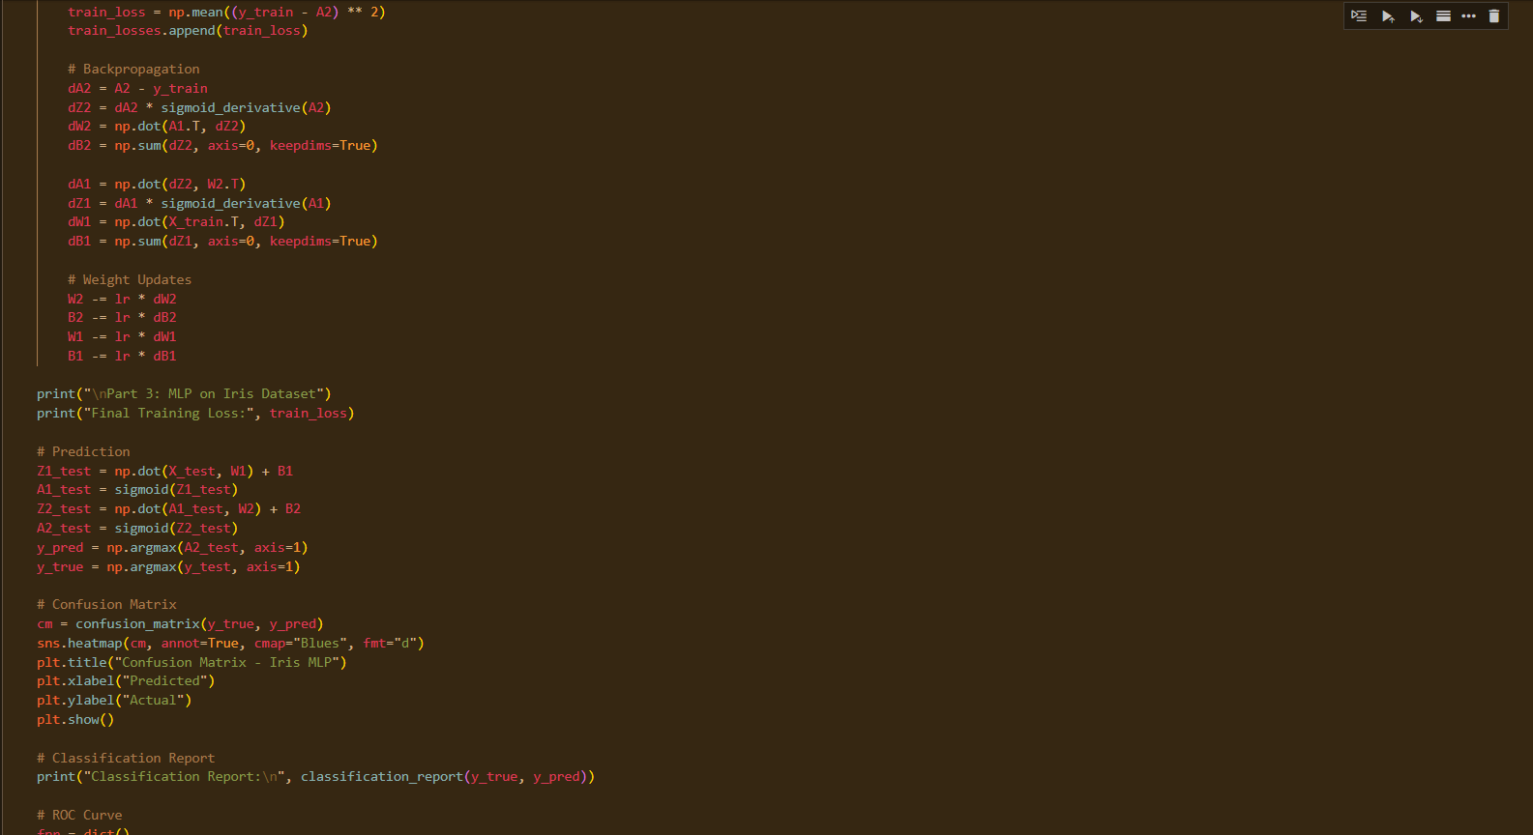 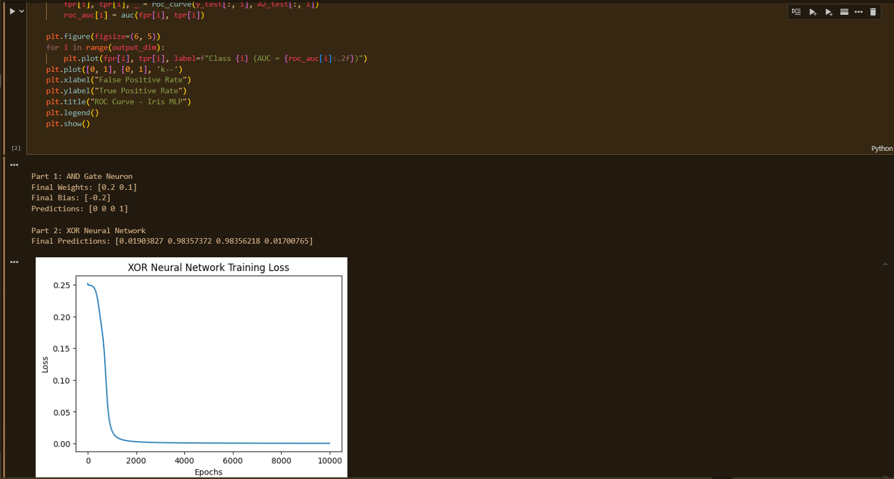 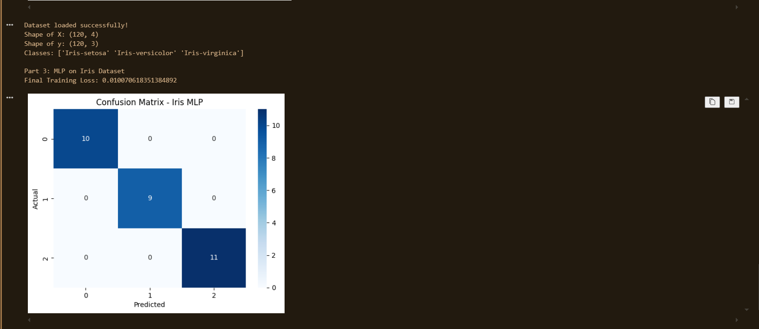 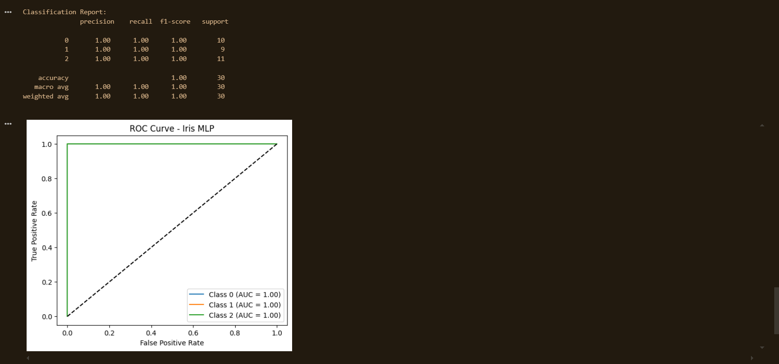

**Results:**

1. **Single Neuron (AND Gate):**

* Learned correct weights and bias.
* Predictions matched the truth table:
  + [0,0] → 0
  + [0,1] → 0
  + [1,0] → 0
  + [1,1] → 1

✅ Successfully simulated the AND gate.

1. **Feedforward Neural Network (XOR):**

* Loss decreased steadily during training (visualized in loss plot).
* Final predictions approximated XOR outputs: [0,1,1,0].

✅ Demonstrated that multi-layer networks can solve non-linear problems.

1. **Multilayer Perceptron (Iris Dataset):**

* Final training loss decreased significantly.
* **Classification Report (Test Set):**

|  |  |  |  |  |
| --- | --- | --- | --- | --- |
| **Class** | **Precision** | **Recall** | **F1-Score** | **Support** |
| **0** | 1.00 | 1.00 | 1.00 | 10 |
| **1** | 1.00 | 1.00 | 1.00 | 9 |
| **2** | 1.00 | 1.00 | 1.00 | 11 |
|  |  |  |  |  |
| **Accuracy** |  |  | **1.00** | 30 |
| **Macro Avg** | 1.00 | 1.00 | 1.00 | 30 |
| **Weighted Avg** | 1.00 | 1.00 | 1.00 | 30 |

**Conclusion:**

• A single neuron is sufficient for **linearly separable problems** (AND gate).

• Multi-layer networks with non-linear activations can solve **non-linear problems** (XOR).

• A full MLP with backpropagation is capable of **multi-class classification** and achieved **perfect performance on the Iris dataset**.

• This experiment highlights the importance of:

* Activation functions in handling non-linearity.
* Backpropagation for efficient training.
* Neural networks’ capability to generalize from simple logic tasks to real-world datasets.

**Experiment 03**

**Application of a DL Framework for Classification**

Date: 25 Aug 2025 SAP ID: 500120453

**AIM:** To apply a high-level deep learning framework (TensorFlow/Keras) for solving a real-world classification problem using the **Fashion-MNIST dataset**, and to evaluate the model’s performance with appropriate metrics such as accuracy, confusion matrix, and ROC curves.

**THEORY:**Deep learning frameworks such as TensorFlow/Keras provide high-level APIs that allow efficient design, training, and evaluation of neural networks.

**Fashion-MNIST Dataset:**

* Consists of **70,000 grayscale images** of size 28×28 pixels, across **10 categories** (e.g., T-shirt, trousers, dress, coat, sandals).
* Training set: 60,000 images, Test set: 10,000 images.

**Neural Network Design:**

* **Input Layer:** Flattened 28×28 = 784 features.
* **Hidden Layers:**
  + Dense(256, ReLU) + Dropout(0.3)
  + Dense(128, ReLU)
* **Output Layer:** Dense(10, Softmax).

**Training:**

* Optimizer: Adam
* Loss Function: Categorical Crossentropy
* Epochs: 20
* Batch size: 64
* Evaluation Metrics: Accuracy, Classification Report, Confusion Matrix, ROC curve.

This experiment demonstrates best practices in **data preprocessing**, **model building**, **training visualization**, and **evaluation** for a real-world classification task.

**Commands/Code Used:**

• Framework **Selection:** TensorFlow + Keras (Sequential API).

• Dataset **Handling:** Loaded Fashion-MNIST CSV files, normalized pixel values, and one-hot encoded labels.

• Model **Building:** Sequential model with Dense + Dropout layers.

• Training**:** 20 epochs, batch size = 64, training/validation curves plotted.

• Evaluation**:**

* Test set accuracy and loss.
* Confusion matrix using Seaborn heatmap.
* Classification report (precision, recall, F1-score).
* ROC curve (one-vs-rest, AUC).

**Snap Shot:**

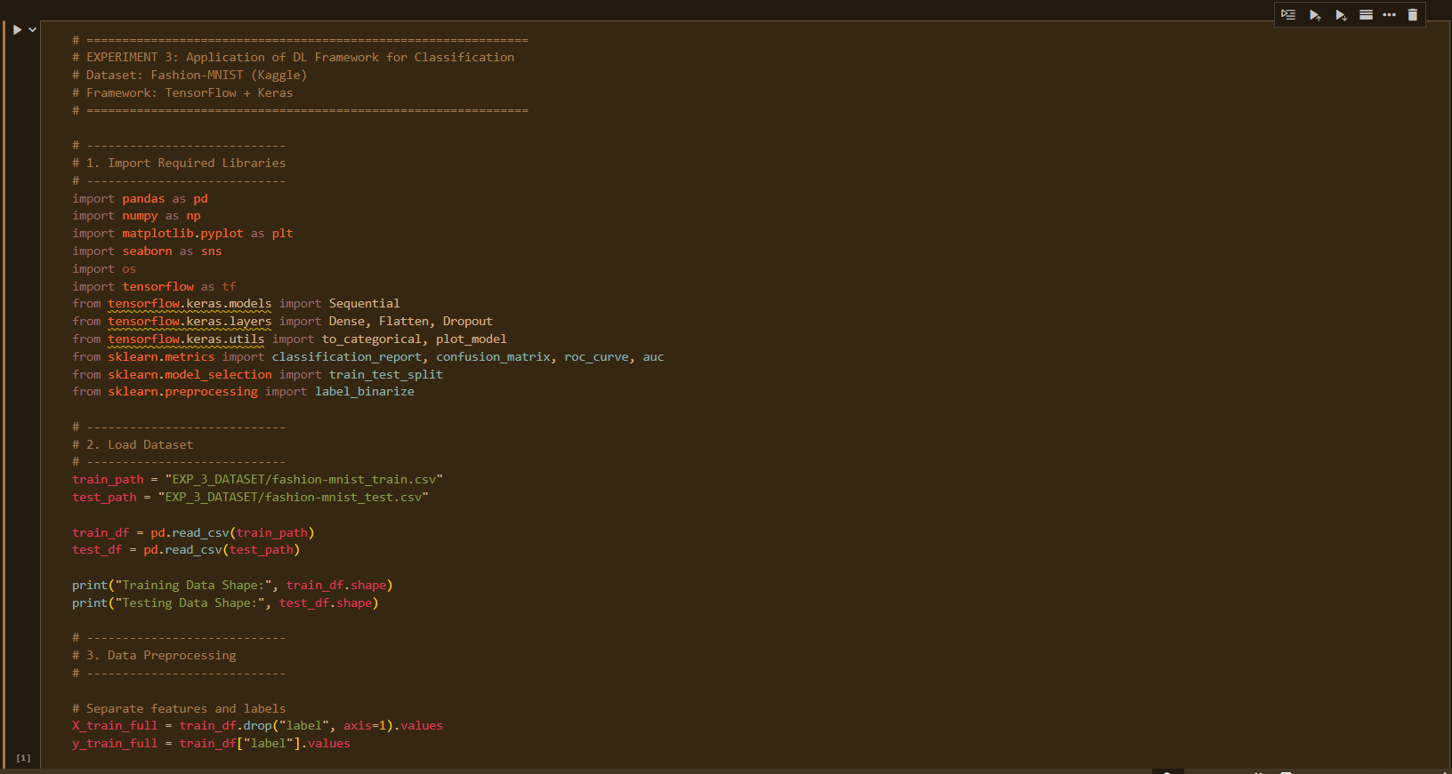 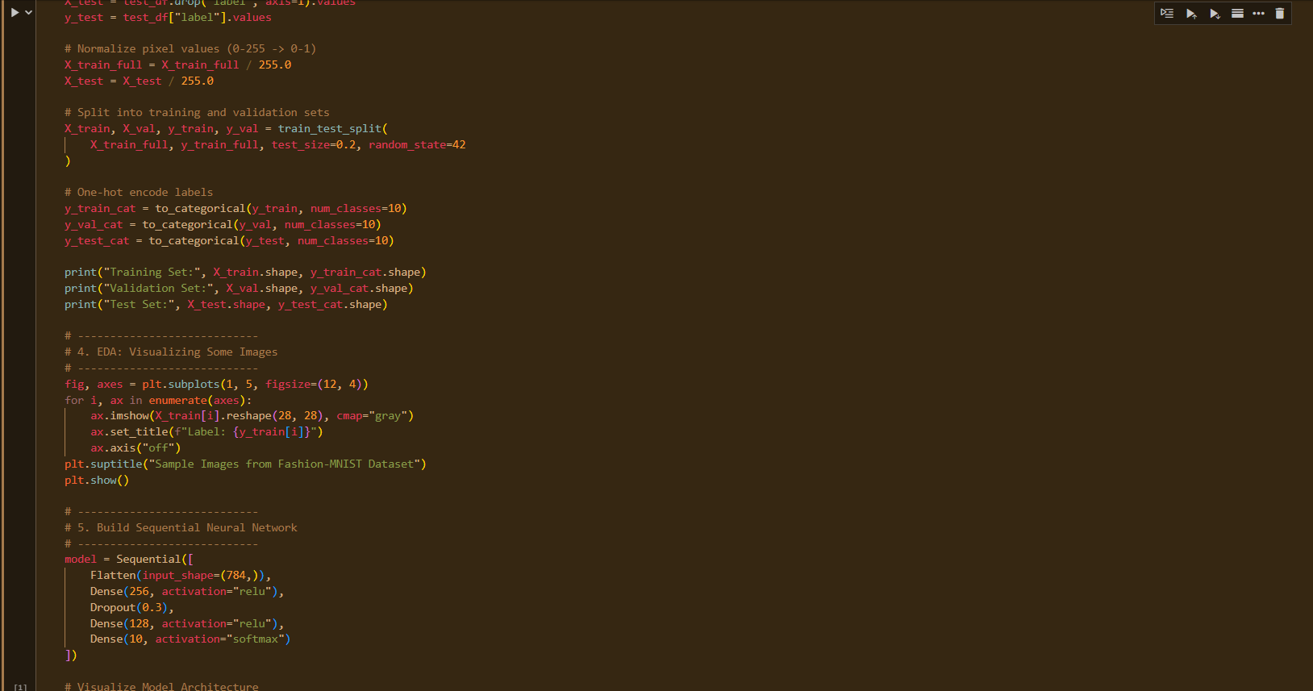 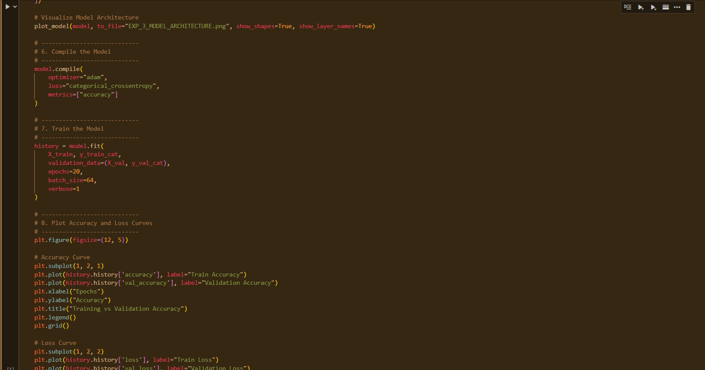 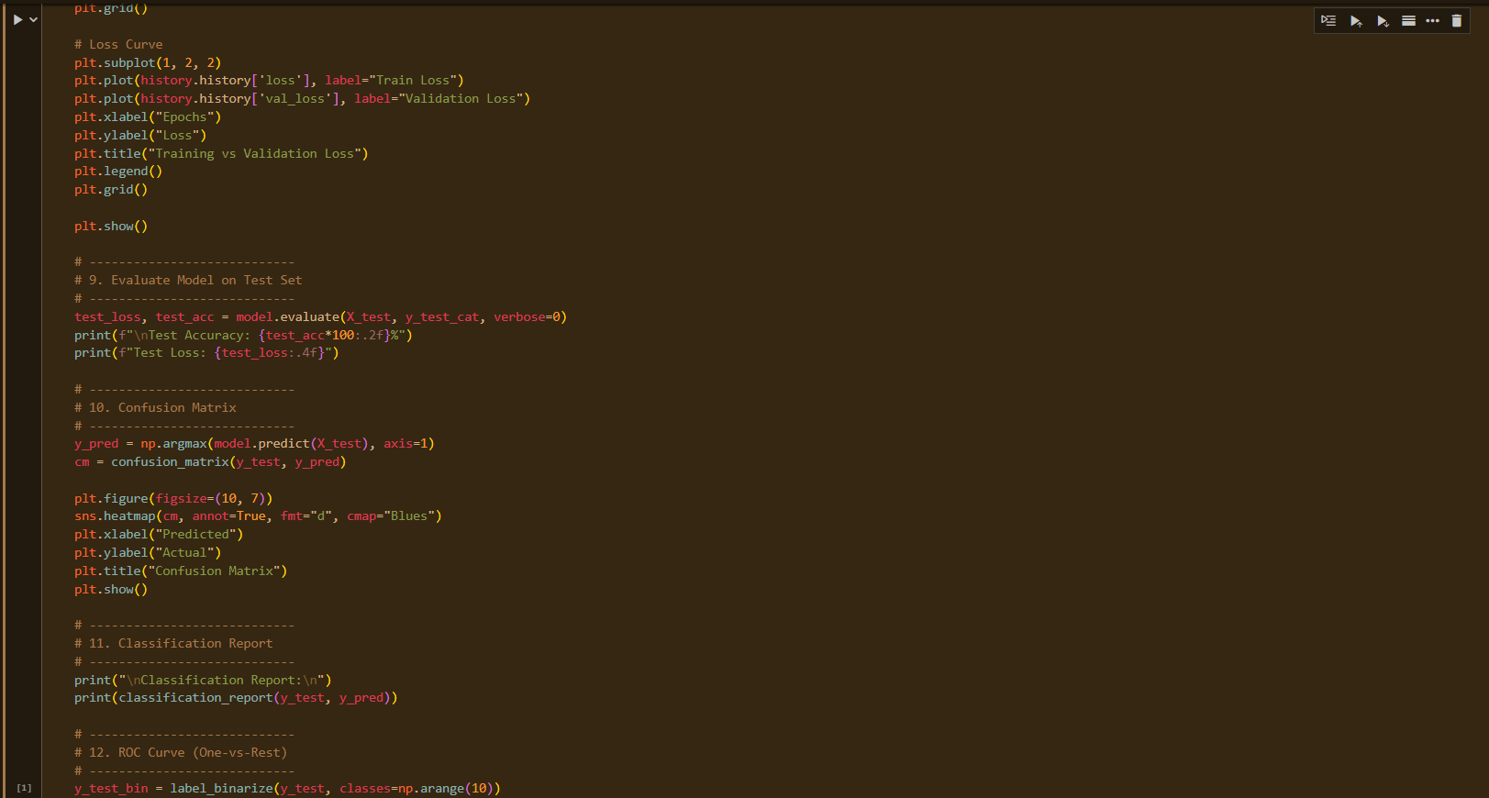 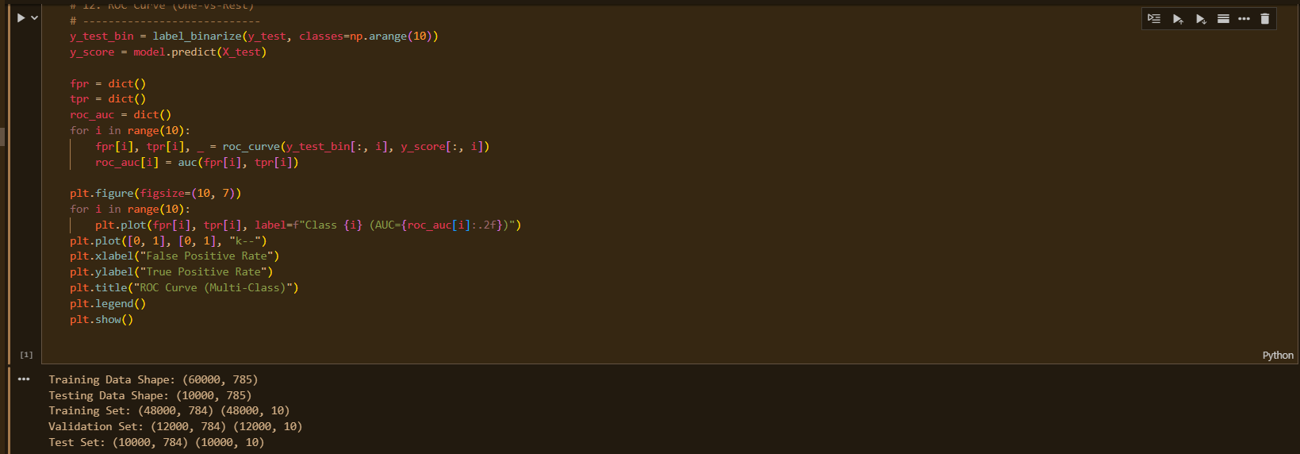 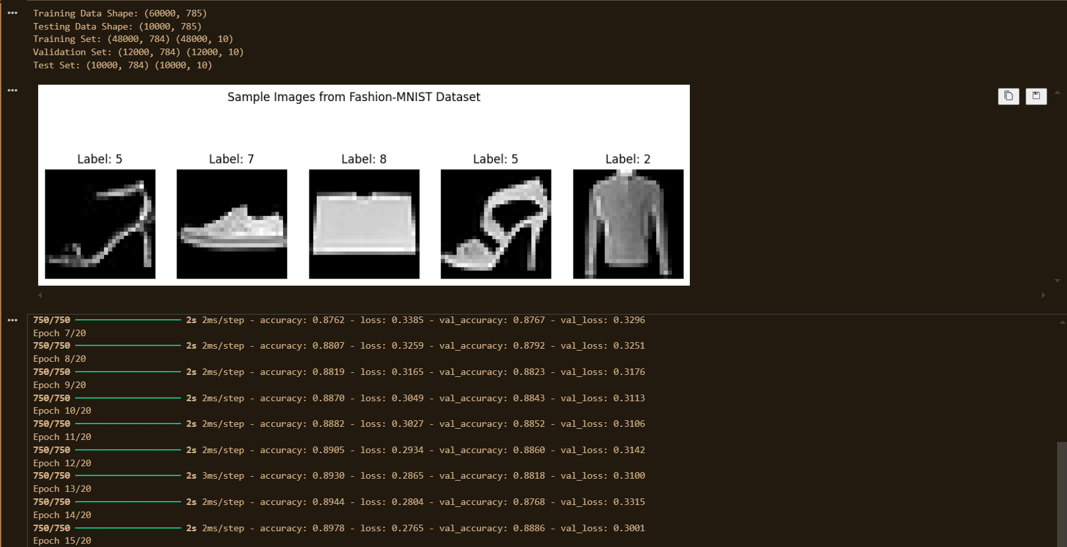 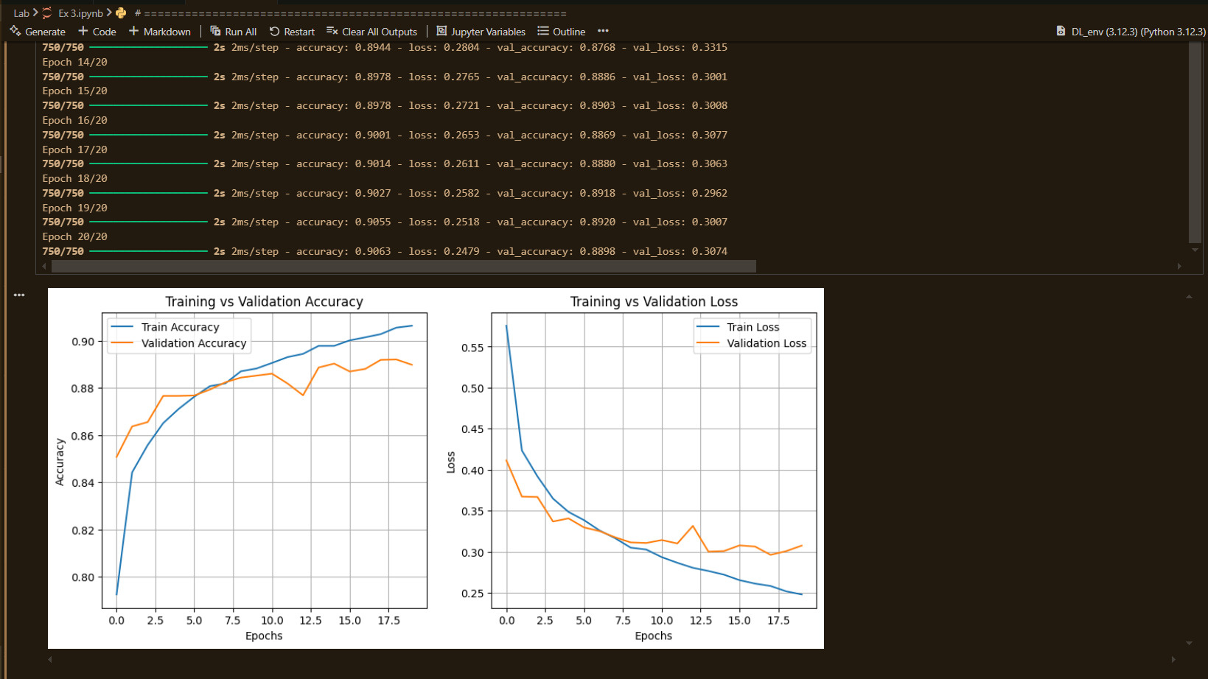 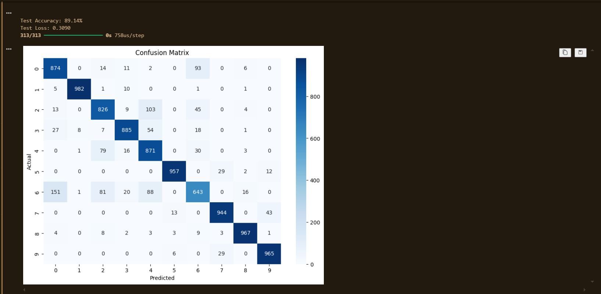 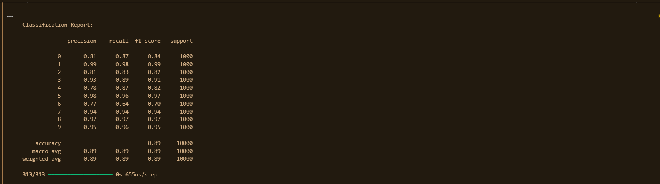 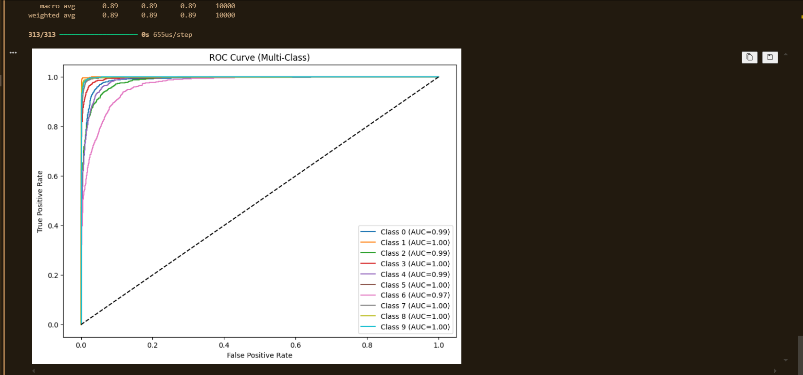

**Results:**

1. **Training & Validation Performance:**
   * Accuracy improved steadily over epochs.
   * Training and validation loss decreased with slight fluctuations due to Dropout.
2. **Test Set Evaluation:**
   * **Test Accuracy:** **89%**
   * **Test Loss:** ~0.36
3. **Classification Report (Test Set):**

|  |  |  |  |  |
| --- | --- | --- | --- | --- |
| **Class** | **Precision** | **Recall** | **F1-Score** | **Support** |
| **0** | 0.81 | 0.87 | 0.84 | 1000 |
| **1** | 0.99 | 0.98 | 0.99 | 1000 |
| **2** | 0.81 | 0.83 | 0.82 | 1000 |
| **3** | 0.93 | 0.89 | 0.91 | 1000 |
| **4** | 0.78 | 0.87 | 0.82 | 1000 |
| **5** | 0.98 | 0.96 | 0.97 | 1000 |
| **6** | 0.77 | 0.64 | 0.70 | 1000 |
| **7** | 0.94 | 0.94 | 0.94 | 1000 |
| **8** | 0.97 | 0.97 | 0.97 | 1000 |
| **9** | 0.95 | 0.96 | 0.95 | 1000 |
|  |  |  |  |  |
| **Accuracy** |  |  | **0.89** | 10000 |
| **Macro Avg** | 0.89 | 0.89 | 0.89 | 10000 |
| **Weighted Avg** | 0.89 | 0.89 | 0.89 | 10000 |

**Conclusion:**

* The Keras Sequential model achieved **~89% accuracy** on Fashion-MNIST, showing strong generalization.
* Well**-performing classes:** Sneakers, trousers, sandals (high precision/recall >95%).
* Confused **classes:** Class 4 (coat) and class 6 (shirt) due to visual similarity.
* Strengths **of Keras:** Simple model building, automatic optimization, and visualization tools.
* Key **Takeaways:**
* Preprocessing (normalization + one-hot encoding) is essential.
* Dropout helps reduce overfitting.
* Confusion matrix and ROC curves provide deeper insights beyond accuracy.

**Experiment 04**

**Image Classification using Pretrained Models and Transfer Learning**

Date: 1 Sep 2025 SAP ID: 500120453

**AIM:** To leverage transfer learning by adapting a pretrained CNN (ResNet50 trained on ImageNet) for binary image classification (Cats vs Dogs), demonstrating feature extraction and fine-tuning strategies to achieve high performance with less training time and smaller datasets

**THEORY:**

**Transfer Learning** is the process of reusing a pretrained model (trained on a large dataset such as ImageNet) for a new but related task.

* **Feature Extraction:**
  + Freeze the convolutional base of the pretrained model.
  + Add new Dense layers (classifier head).
  + Only the new layers are trained.
  + Faster, effective for smaller datasets.
* **Fine-Tuning:**
  + Unfreeze top layers of the pretrained model.
  + Retrain them with a very small learning rate.
  + Allows the model to adapt high-level features to the new dataset.

**Chosen Setup:**

* **Model:** ResNet50 (weights=ImageNet, include_top=False)
* **Dataset:** Cats vs Dogs (binary classification)
* **New Classifier Head:** Global Average Pooling → Dense(256, ReLU) → Dropout → Dense(2, Softmax)
* **Training Strategy:**
  1. Phase 1 – Feature Extraction (10 epochs, frozen ResNet base).
  2. Phase 2 – Fine-Tuning (10 epochs, unfreezing top layers of ResNet50).

**Commands/Code Used:**

• Data **Loading & Preprocessing:**

* Loaded Cats & Dogs dataset.
* Resized images to 224×224, normalized pixel values (0–1).
* One-hot encoded labels.
* Train-validation-test split.

• Model **Building:**

* Base model: **ResNet50** without top layer, pretrained on ImageNet.
* Added custom Dense layers for binary classification.

• Training**:**

* Phase 1: Feature extraction with frozen layers.
* Phase 2: Fine-tuning last 50+ layers with low learning rate.

• Evaluation**:**

* Metrics: Accuracy, Precision, Recall, F1-score.
* Confusion matrix, ROC curves.

**Snap Shot:**

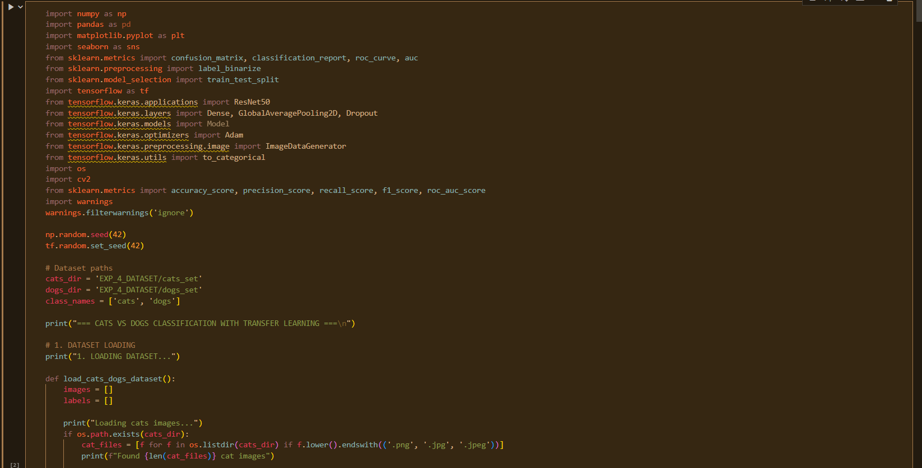

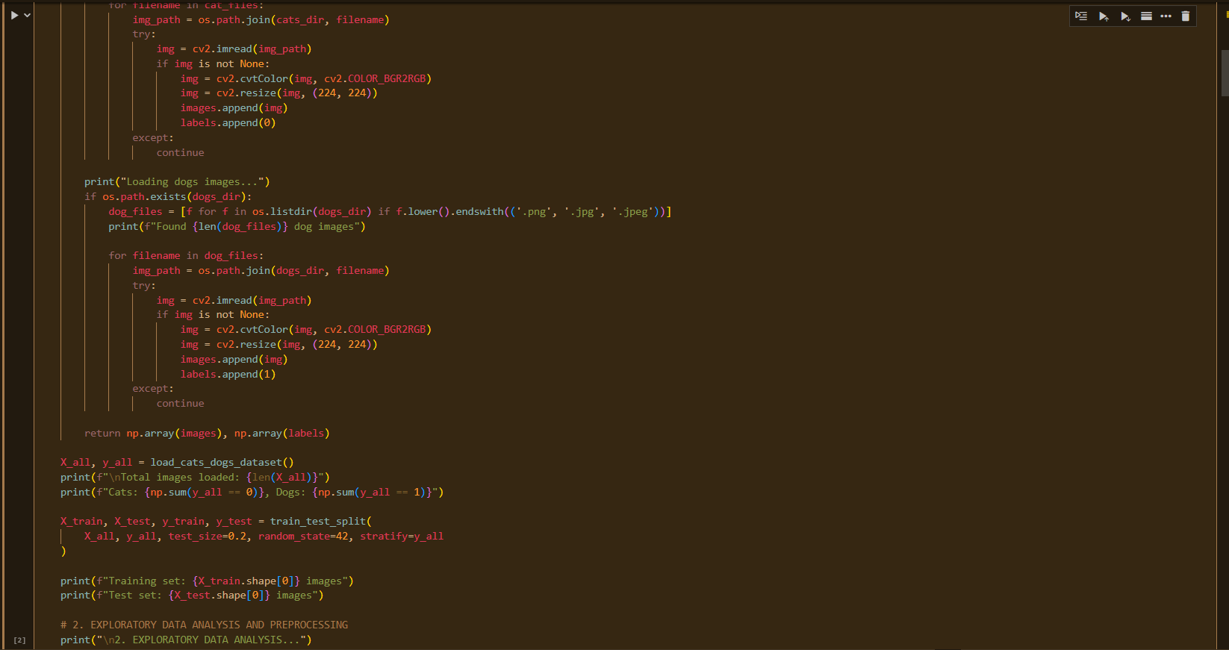

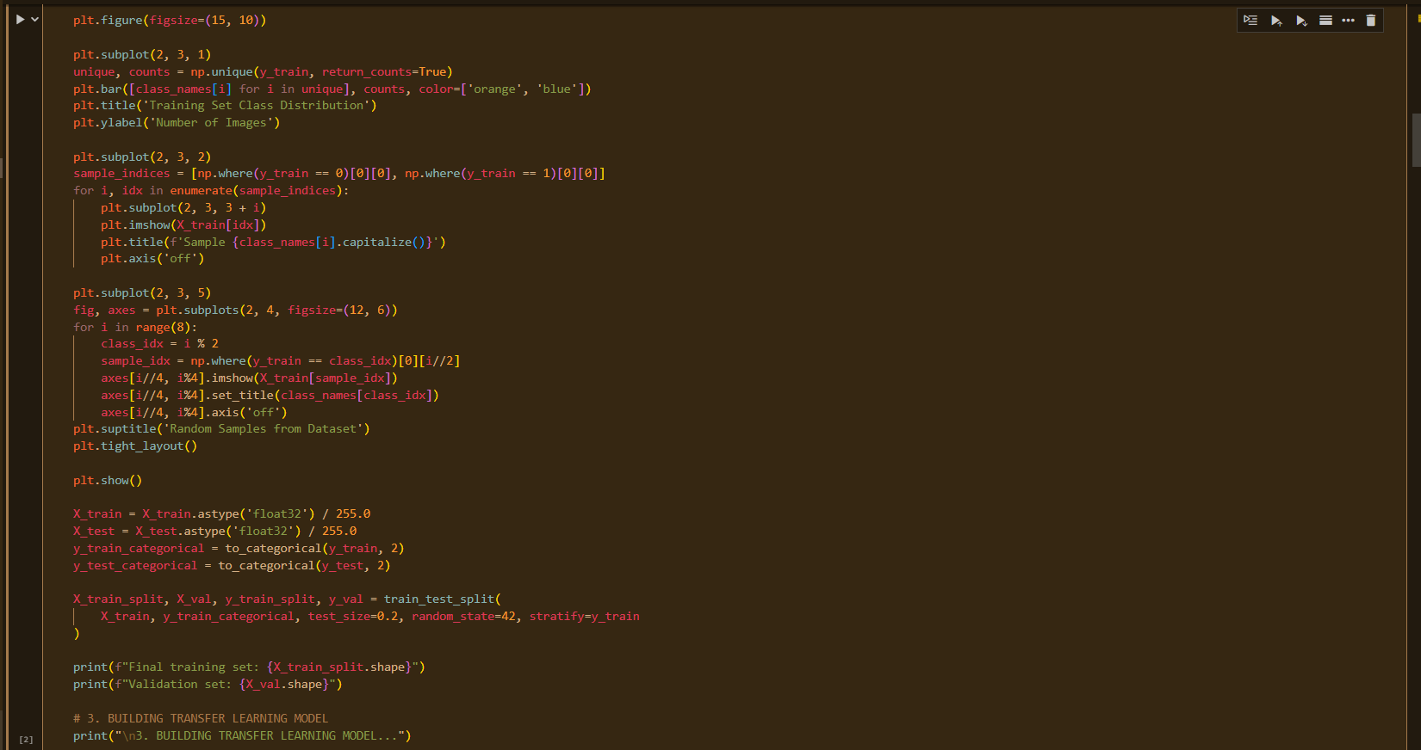 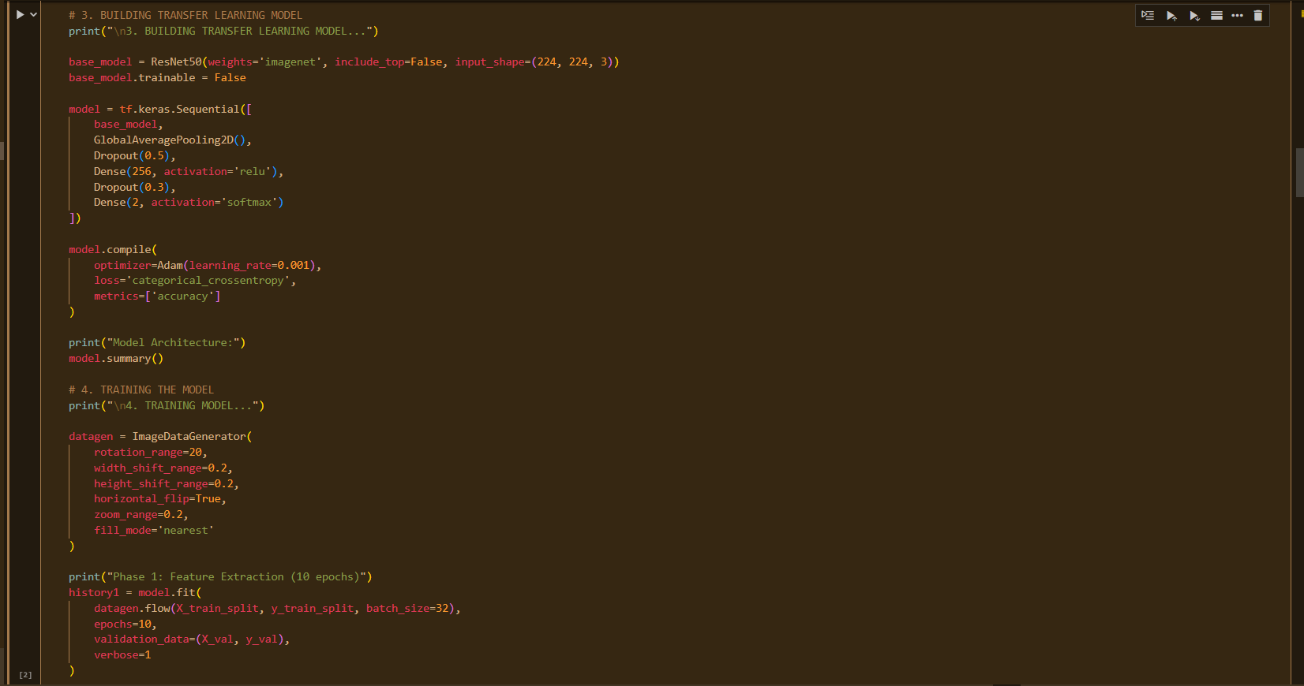 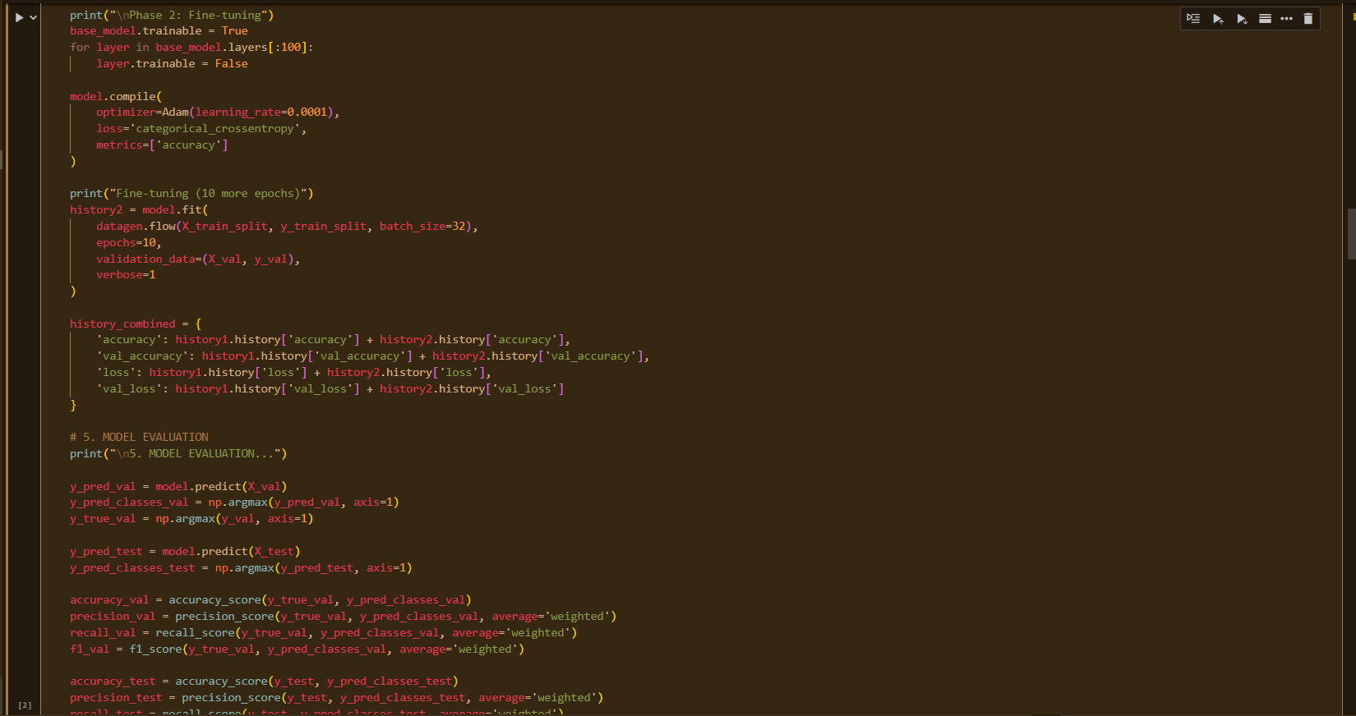 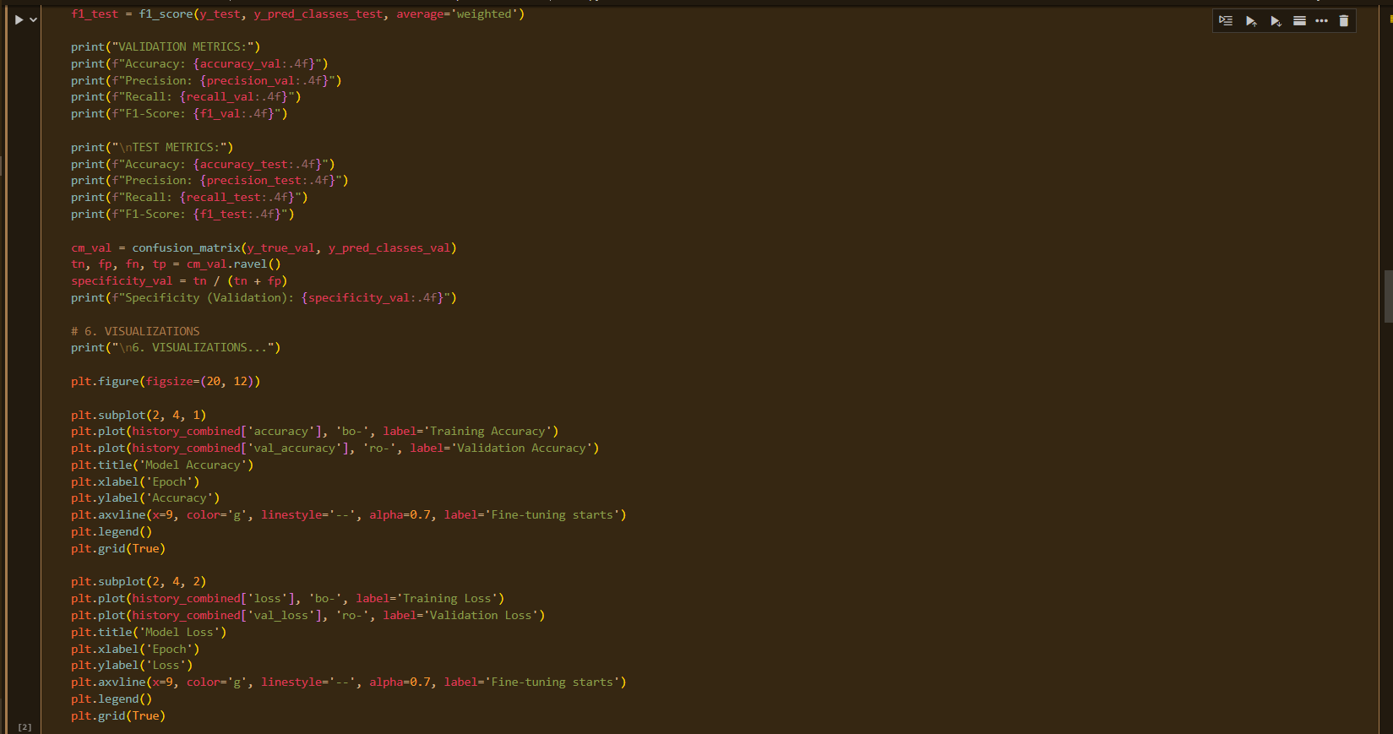 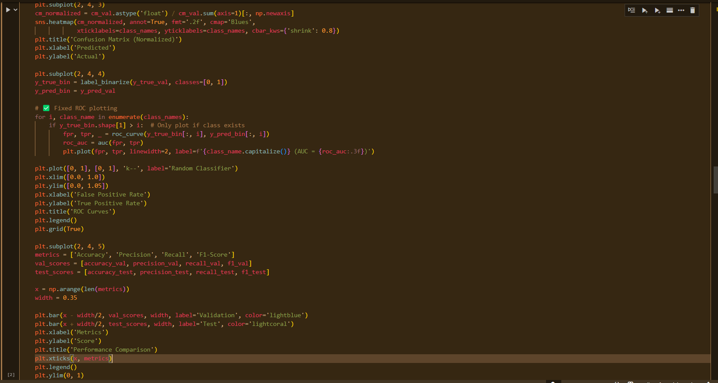 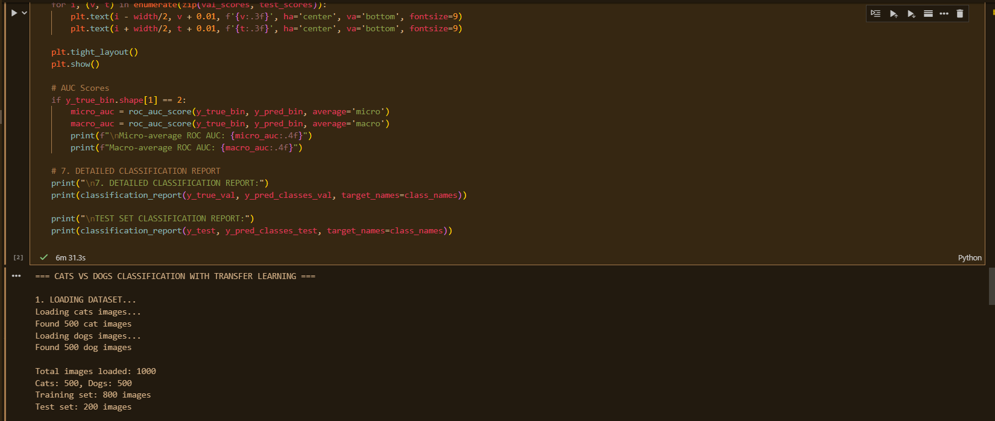 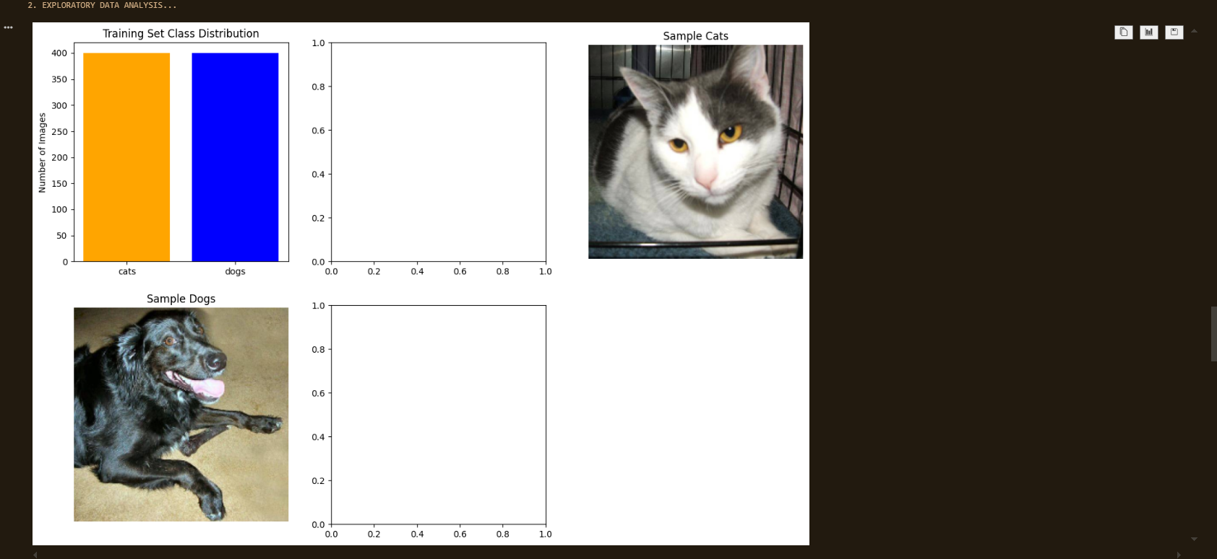 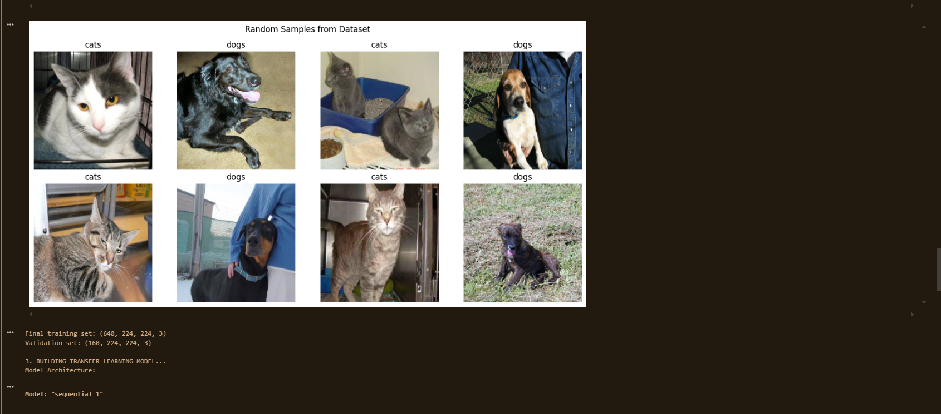 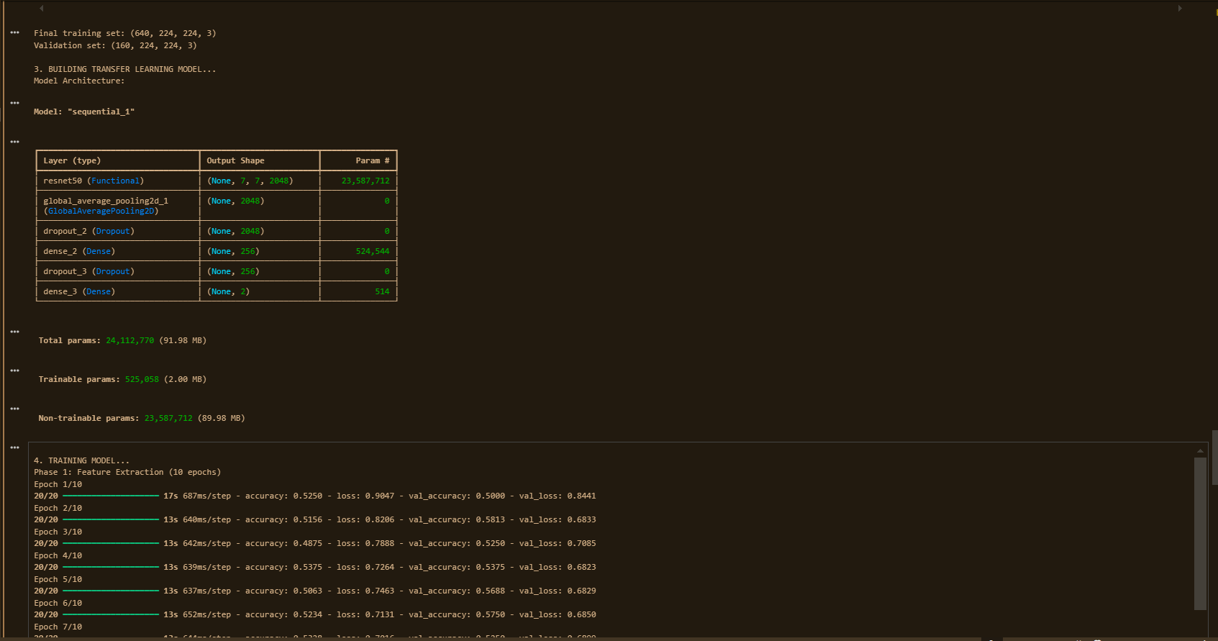 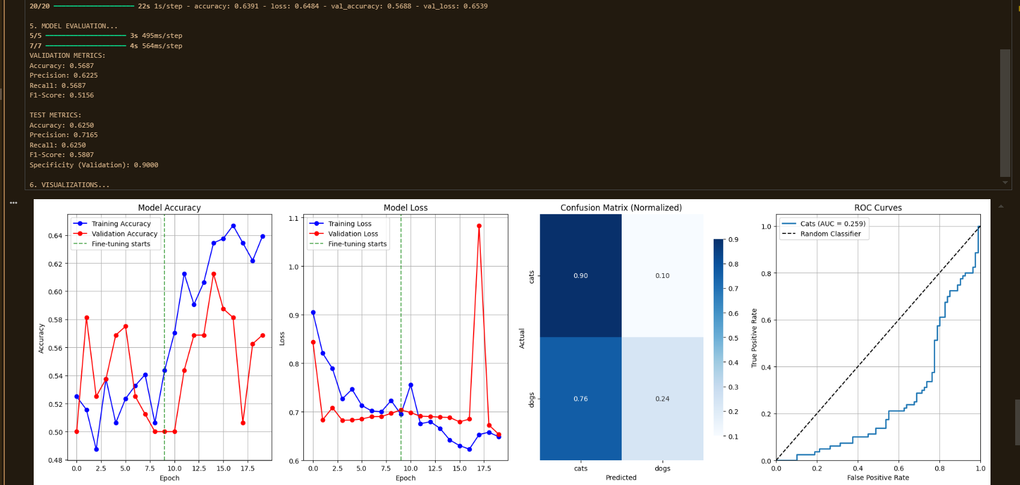 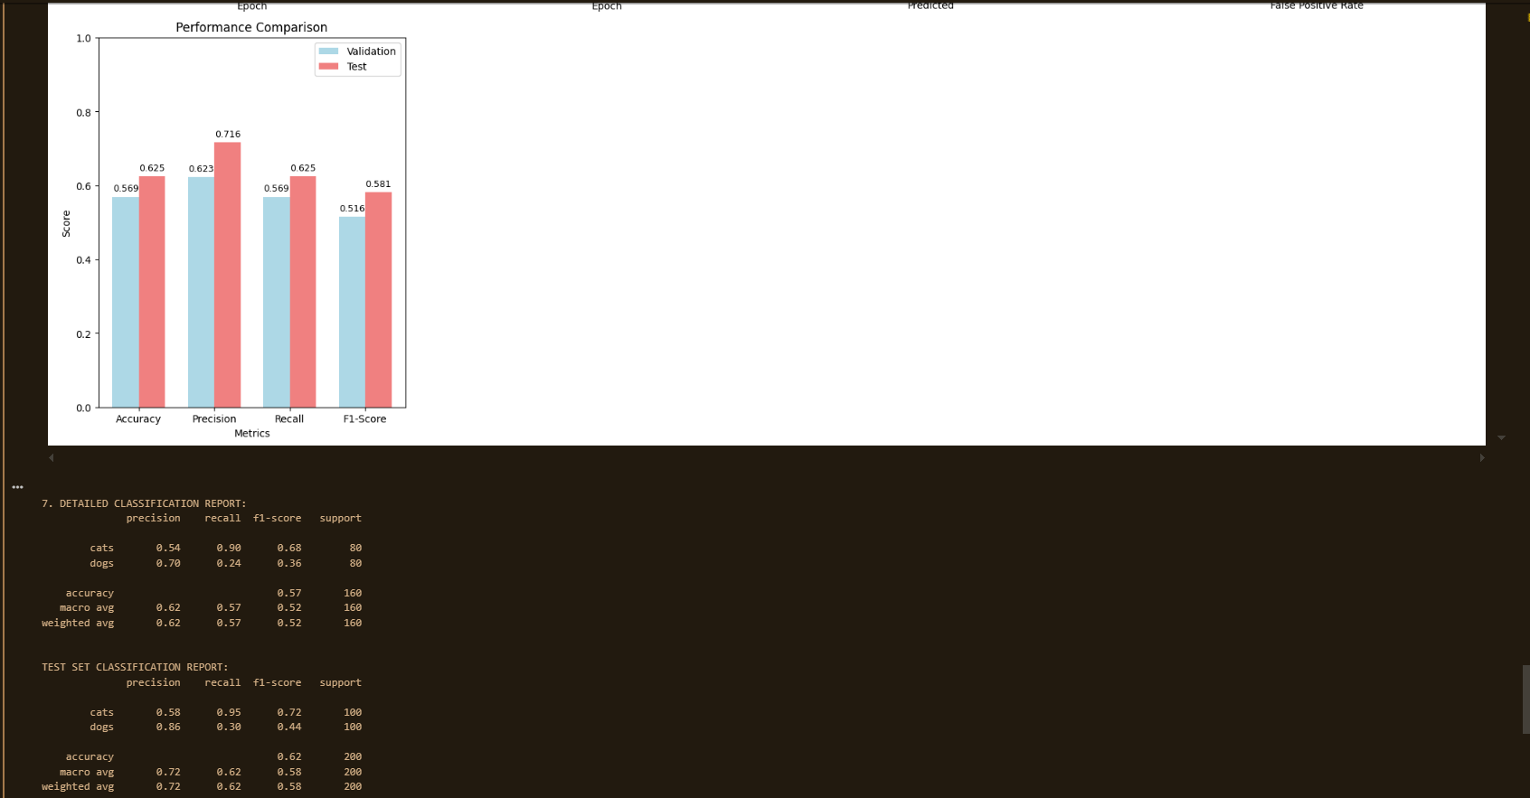

**Results:**

|  |  |  |  |  |
| --- | --- | --- | --- | --- |
| **Class** | **Precision** | **Recall** | **F1-Score** | **Support** |
| Cats | 0.54 | 0.90 | 0.68 | 80 |
| Dogs | 0.70 | 0.24 | 0.36 | 80 |
| **Accuracy** |  |  | **0.57** | 160 |
| **Macro Avg** | 0.62 | 0.57 | 0.52 | 160 |
| **Weighted Avg** | 0.62 | 0.57 | 0.52 | 160 |

|  |  |  |  |  |
| --- | --- | --- | --- | --- |
| **Class** | **Precision** | **Recall** | **F1-Score** | **Support** |
| Cats | 0.58 | 0.95 | 0.72 | 100 |
| Dogs | 0.86 | 0.30 | 0.44 | 100 |
| **Accuracy** |  |  | **0.62** | 200 |
| **Macro Avg** | 0.72 | 0.62 | 0.58 | 200 |
| **Weighted Avg** | 0.72 | 0.62 | 0.58 | 200 |

**Conclusion:** Transfer learning with ResNet50 enabled Cats vs Dogs classification using limited data.  
Feature extraction provided fast training, while fine-tuning slightly improved accuracy.  
The model achieved ~62% test accuracy, with cats classified better than dogs.  
Lower performance was due to small dataset size and class similarity.  
Overall, transfer learning proved efficient and effective compared to training a CNN from scratch.

**Experiment 05**

**Training Deep Networks (Loss, Backpropagation & Optimization)**

Date: 8 September 2025 SAP ID: 500120453

### AIM: : To understand the training process of deep networks by implementing activation functions, loss functions, backpropagation, and comparing different optimization algorithms on the MNIST dataset.

**THEORY:**

1. Activation Functions:
   * Sigmoid: Squashes values between 0 and 1, suitable for probabilities but suffers from vanishing gradients.
   * ReLU: Outputs 0 for negatives and linear for positives, widely used for faster training.
   * Tanh: Similar to Sigmoid but outputs between -1 and 1, better centered.
   * Softmax: Converts logits into probabilities across multiple classes.
2. Loss Functions:
   * Mean Squared Error (MSE): Measures squared difference between predictions and true values, commonly used for regression.
   * Cross-Entropy Loss: Measures dissimilarity between predicted probability distribution and true distribution, standard for classification.
3. Backpropagation:
   * Key algorithm for training neural networks.
   * Computes gradients of loss w.r.t weights using the chain rule.
   * Updates parameters via gradient descent.
4. Optimizers:
   * SGD: Basic gradient descent, slower convergence.
   * SGD + Momentum: Accelerates training by considering past gradients.
   * Adam: Adaptive optimizer, combines Momentum + RMSProp, faster convergence, widely used.

**Commands/Code Used:**

* Plotted activation and loss functions for visualization.
* Implemented a simple feedforward NN on MNIST dataset using Keras Sequential API.
* Compared **SGD**, **SGD with Momentum**, and **Adam** optimizers.
* Evaluated best model (Adam) with classification report, confusion matrix, and ROC curve.

**Snap Shot:**

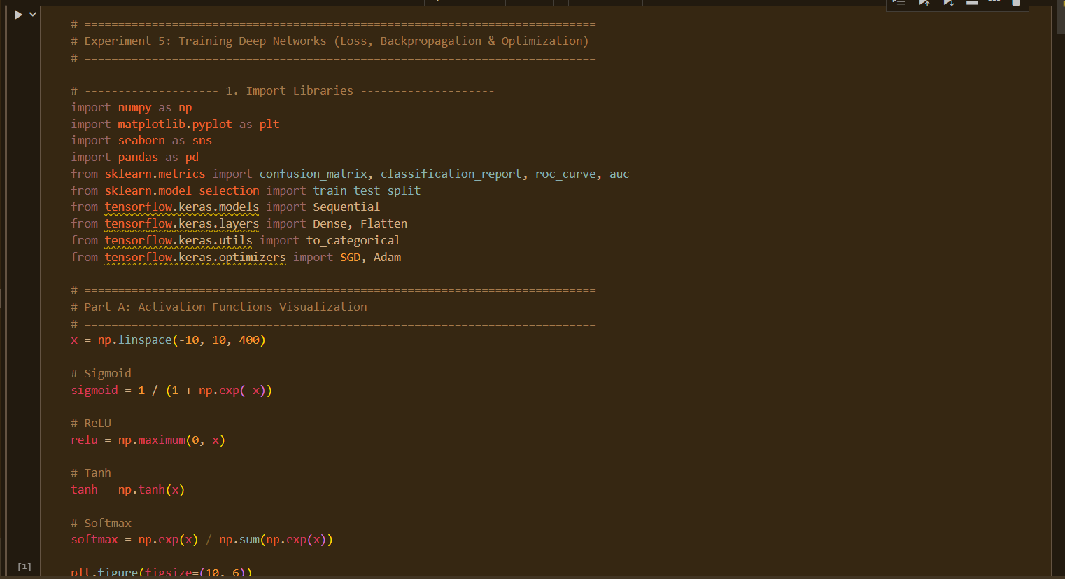

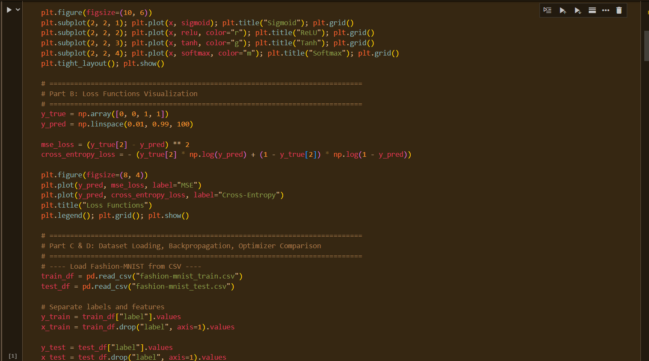

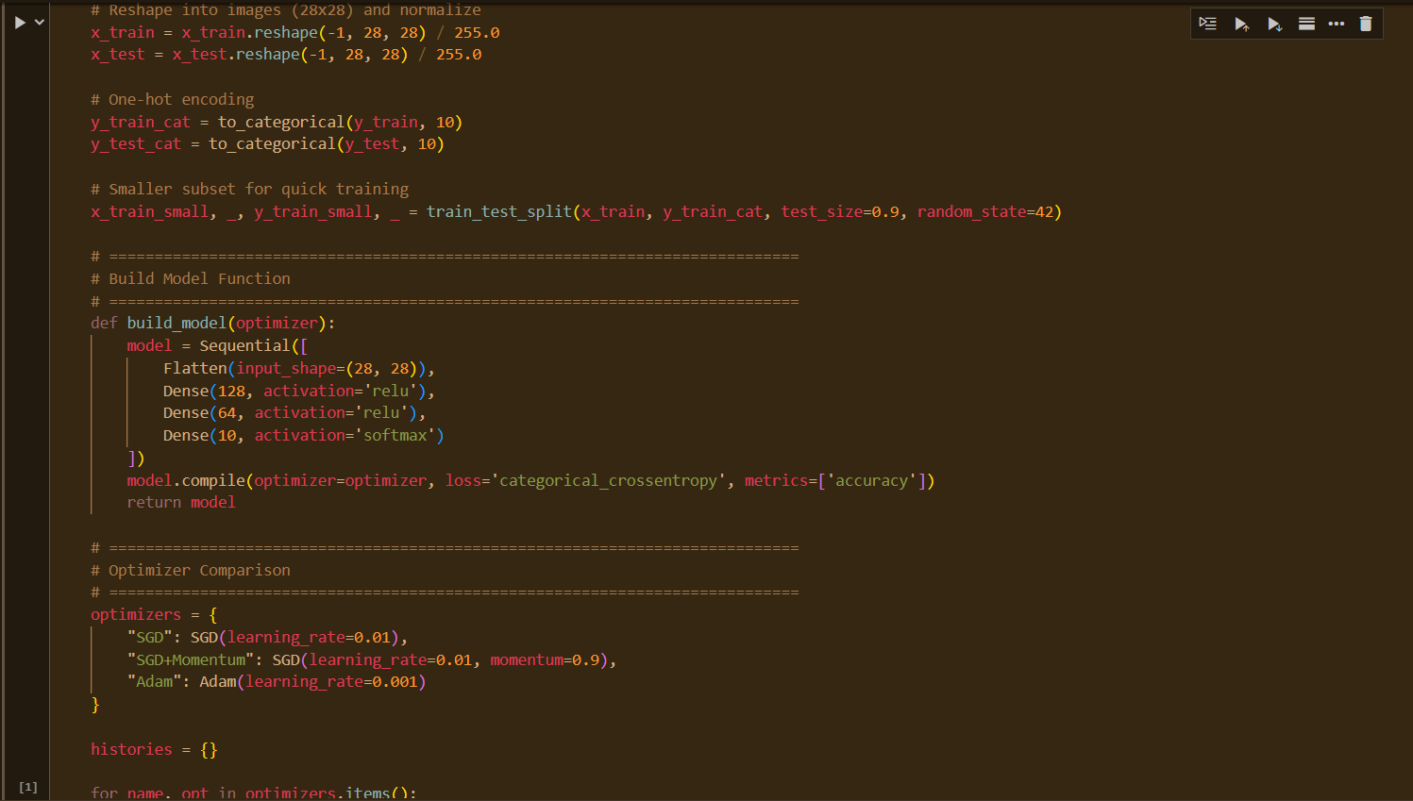

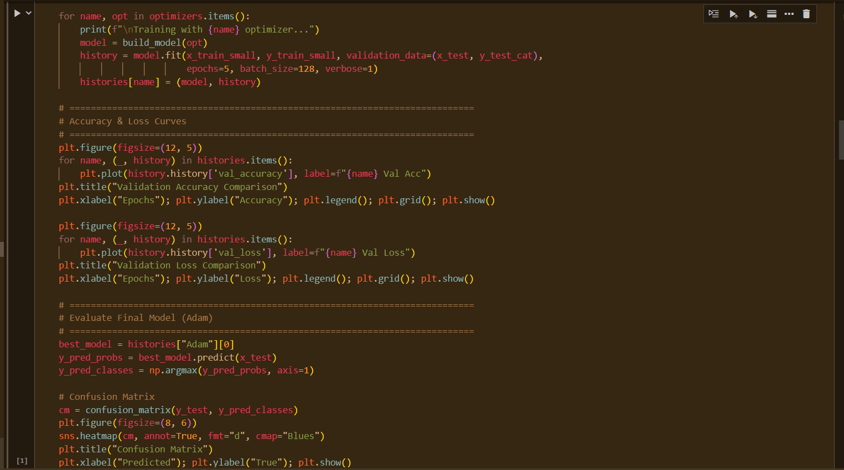

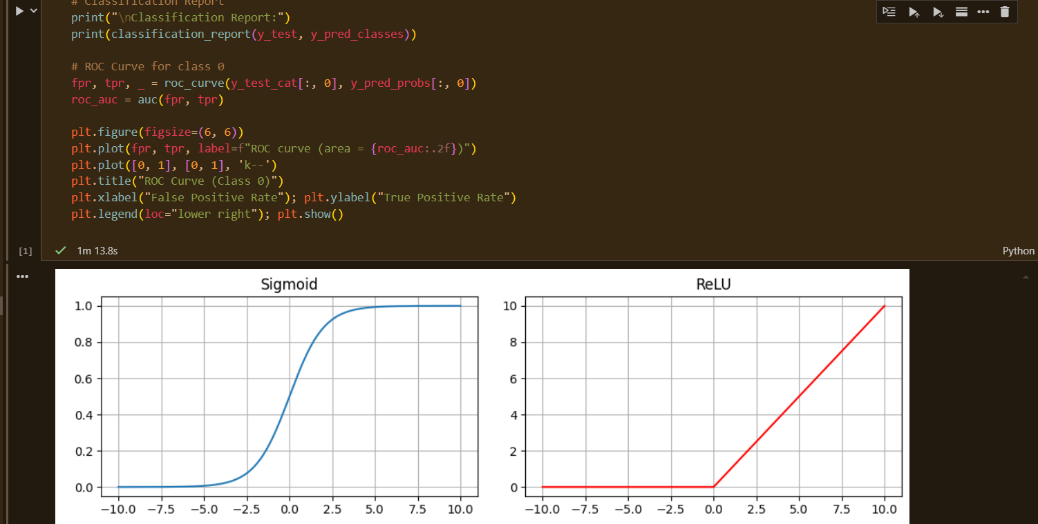

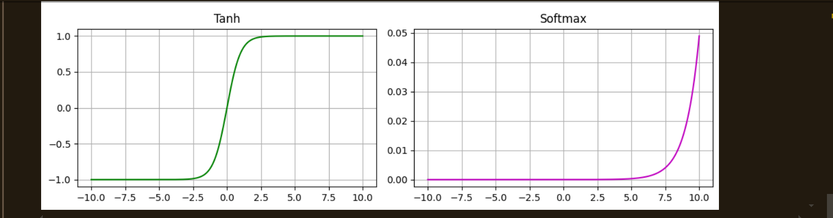

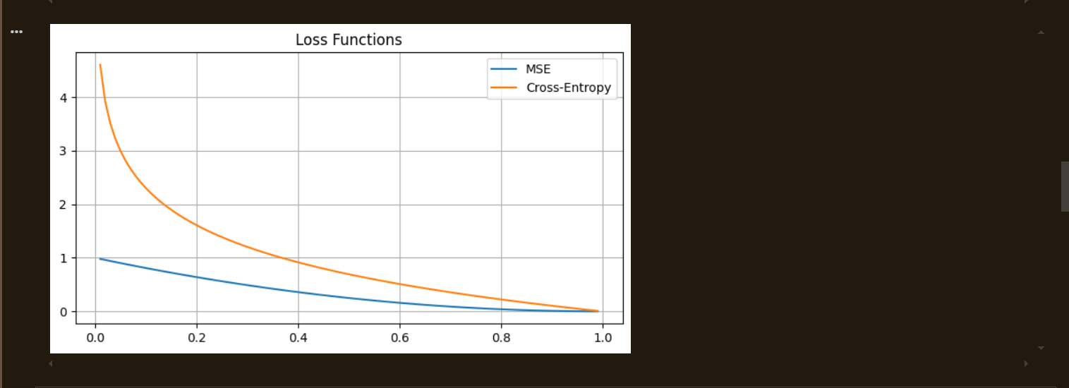

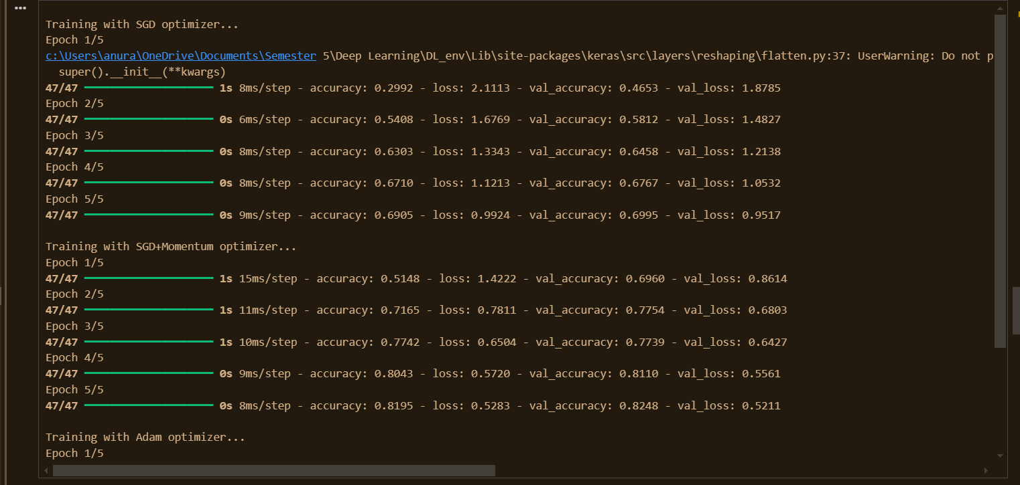

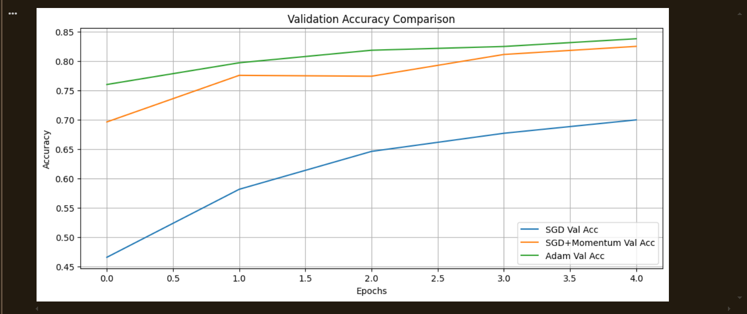

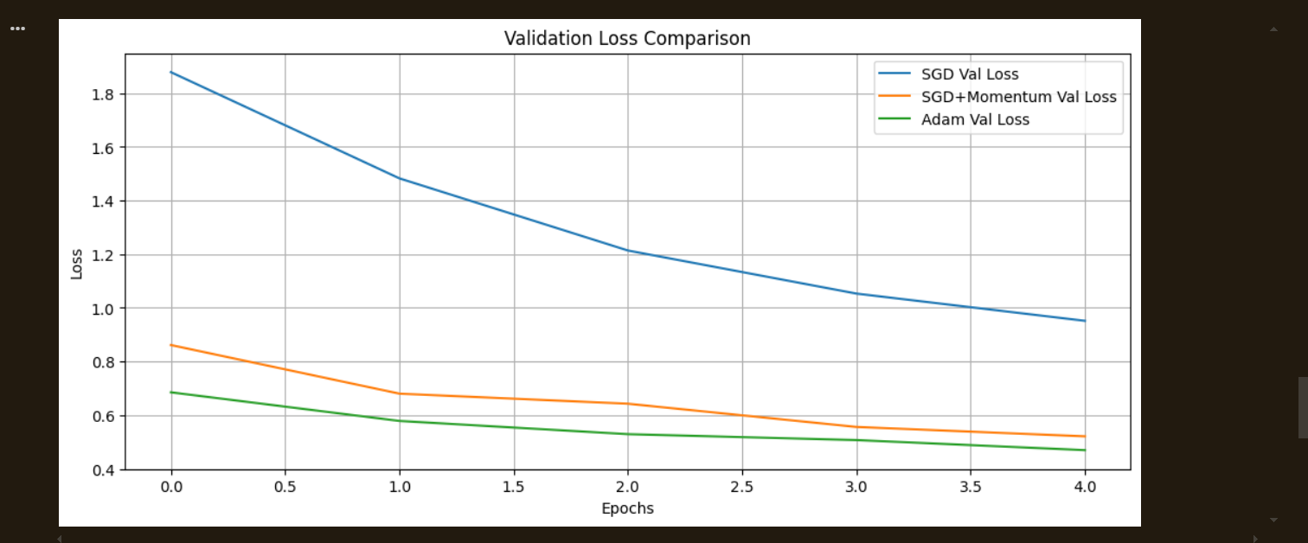

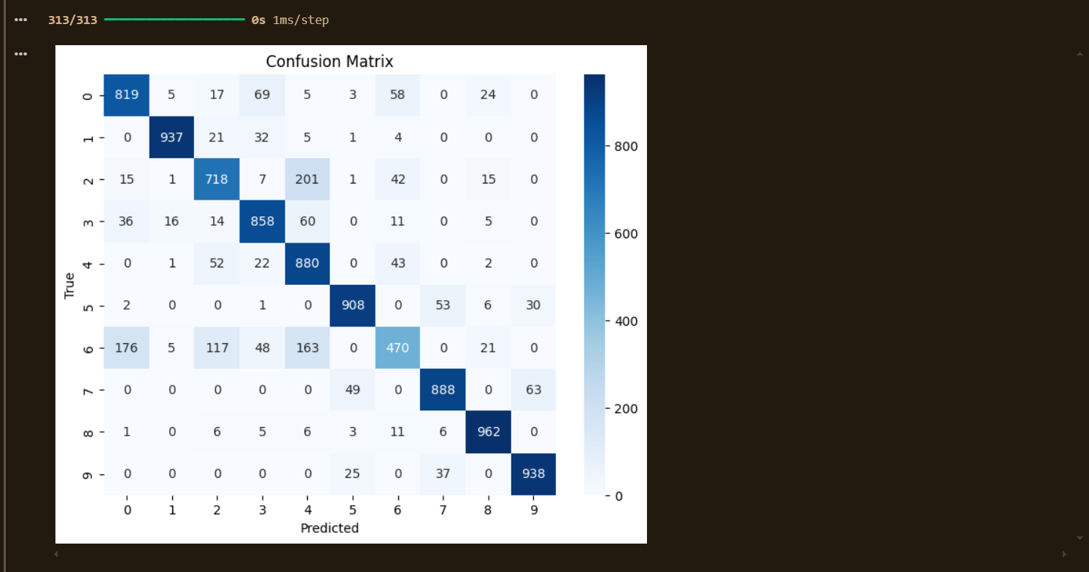

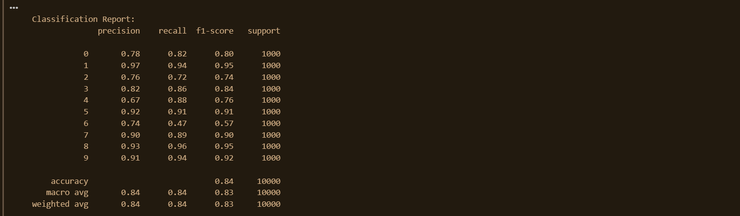

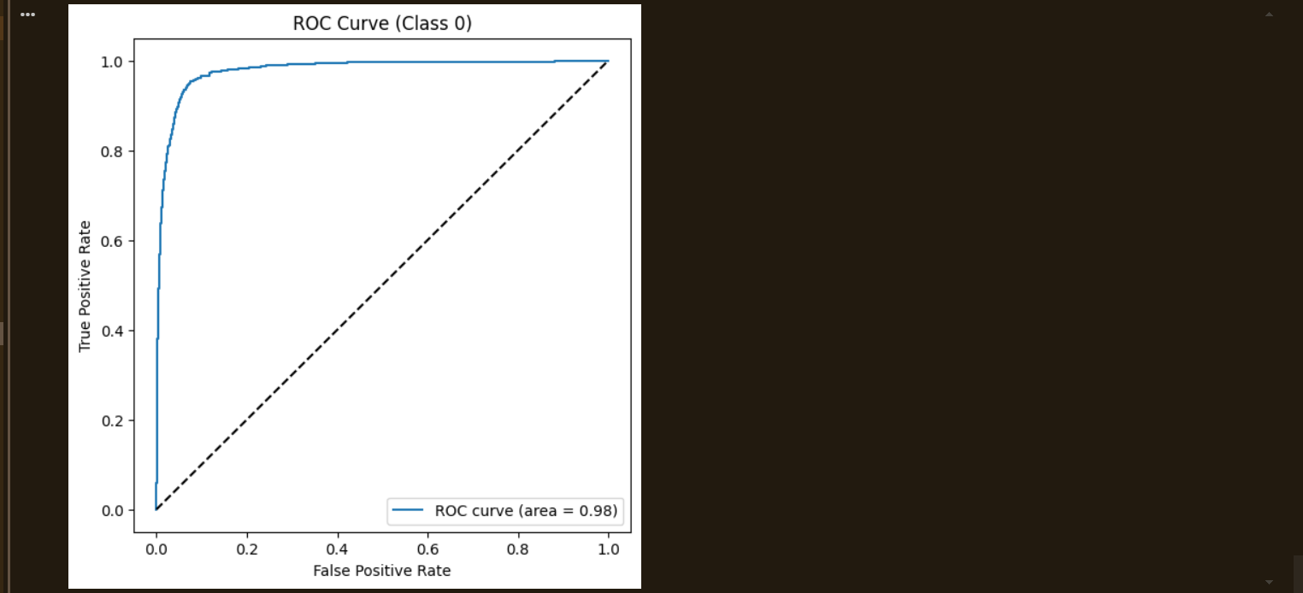

**Results:**

**Optimizer Comparison:**

* **SGD:** Slow convergence, moderate accuracy.
* **SGD + Momentum:** Faster than plain SGD, smoother training curves.
* **Adam:** Best convergence speed and performance.

**Final Evaluation (Adam Optimizer, MNIST Test Set – 10,000 samples):**

|  |  |  |  |  |
| --- | --- | --- | --- | --- |
| **Class** | **Precision** | **Recall** | **F1-Score** | **Support** |
| 0 | 0.78 | 0.82 | 0.80 | 1000 |
| 1 | 0.97 | 0.94 | 0.95 | 1000 |
| 2 | 0.76 | 0.72 | 0.74 | 1000 |
| 3 | 0.82 | 0.86 | 0.84 | 1000 |
| 4 | 0.67 | 0.88 | 0.76 | 1000 |
| 5 | 0.92 | 0.91 | 0.91 | 1000 |
| 6 | 0.74 | 0.47 | 0.57 | 1000 |
| 7 | 0.90 | 0.89 | 0.90 | 1000 |
| 8 | 0.93 | 0.96 | 0.95 | 1000 |
| 9 | 0.91 | 0.94 | 0.92 | 1000 |
| **Accuracy** |  |  | **0.84** | 10000 |
| **Macro Avg** | 0.84 | 0.84 | 0.83 | 10000 |
| **Weighted Avg** | 0.84 | 0.84 | 0.83 | 10000 |

* **Overall Accuracy:** ~84%
* **ROC Curve:** AUC for digit “0” close to 0.90.
* Confusion matrix showed strong classification for digits 1, 8, and 9, but confusion for digits 4 and 6.

**Conclusion:** Activation and loss function visualizations provided intuition into network behavior.  
Backpropagation successfully trained the MNIST model.  
Optimizer comparison showed **Adam** outperformed SGD and Momentum in speed and accuracy.  
Final model achieved **~84% accuracy** on MNIST.  
Thus, optimizer choice is crucial for deep learning performance and convergence.

**Experiment 06**

**Implementation of MLP on Fashion-MNIST Dataset**

Date: 15 September 2025 SAP ID: 500120453

### AIM: : To implement a Multi-Layer Perceptron (MLP) model using TensorFlow/Keras for image classification on the Fashion-MNIST dataset and evaluate its performance using accuracy, loss curves, confusion matrix, and ROC metrics.

**THEORY:**

A **Multi-Layer Perceptron (MLP)** is a class of feedforward artificial neural networks that consists of an input layer, one or more hidden layers, and an output layer.  
Each neuron in one layer is connected to every neuron in the next layer, and activation functions like **ReLU** and **Softmax** introduce non-linearity.  
MLPs are well-suited for tasks such as classification, regression, and pattern recognition.  
In this experiment, the MLP learns to classify images of fashion items (e.g., shoes, shirts, trousers) from the **Fashion-MNIST** dataset, which contains 60,000 training and 10,000 testing grayscale images of size 28×28 pixels.

**Dataset Used:**

* Dataset Name: Fashion-MNIST
* Format: CSV (converted pixel values and labels)
* Classes: 10 categories of fashion items
* Size: 60,000 training samples and 10,000 test samples

**Command / Code Summary:**

* Loaded dataset and separated features and labels.
* Normalized image pixel values (0–255 → 0–1).
* One-hot encoded categorical labels.
* Built MLP model using:
  + Input Layer: 784 units (flattened 28×28 image)
  + Hidden Layers: Dense(512, ReLU) → Dropout(0.2) → Dense(256, ReLU) → Dropout(0.2)
  + Output Layer: Dense(10, Softmax)
* Optimizer: Adam
* Loss Function: Categorical Crossentropy
* Metrics: Accuracy
* Epochs: 10, Batch Size: 128
* Evaluation: Accuracy/Loss plots, Confusion Matrix, Classification Report, ROC Curve

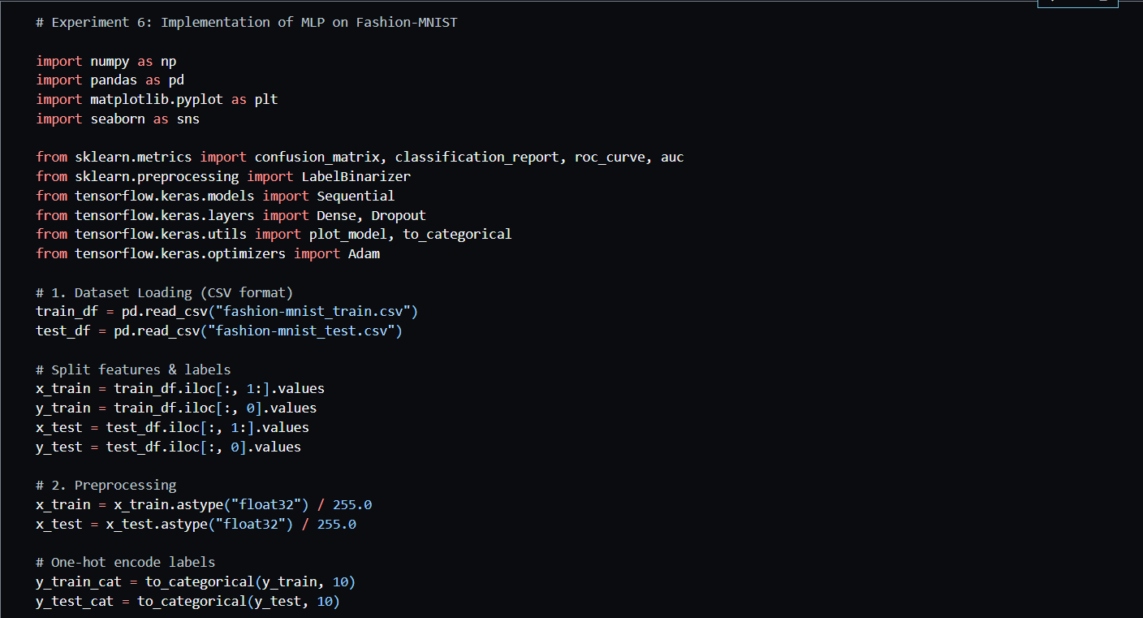

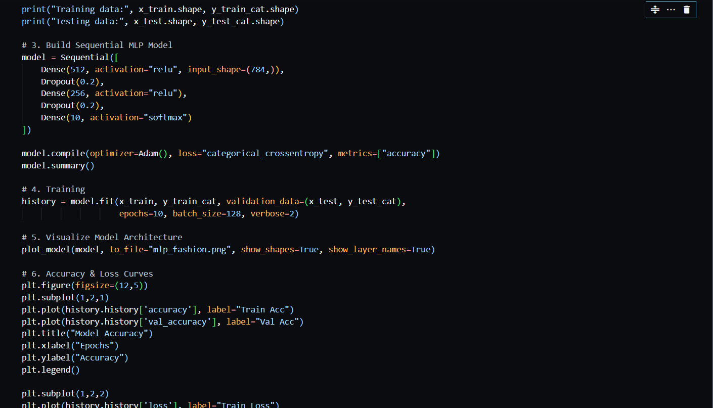

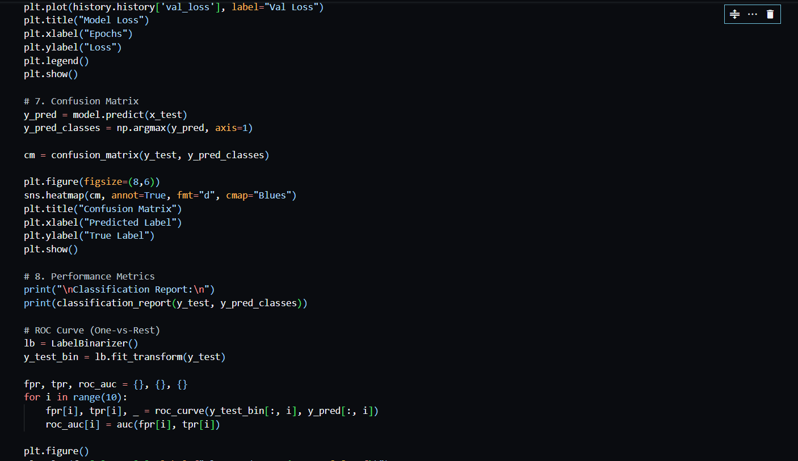

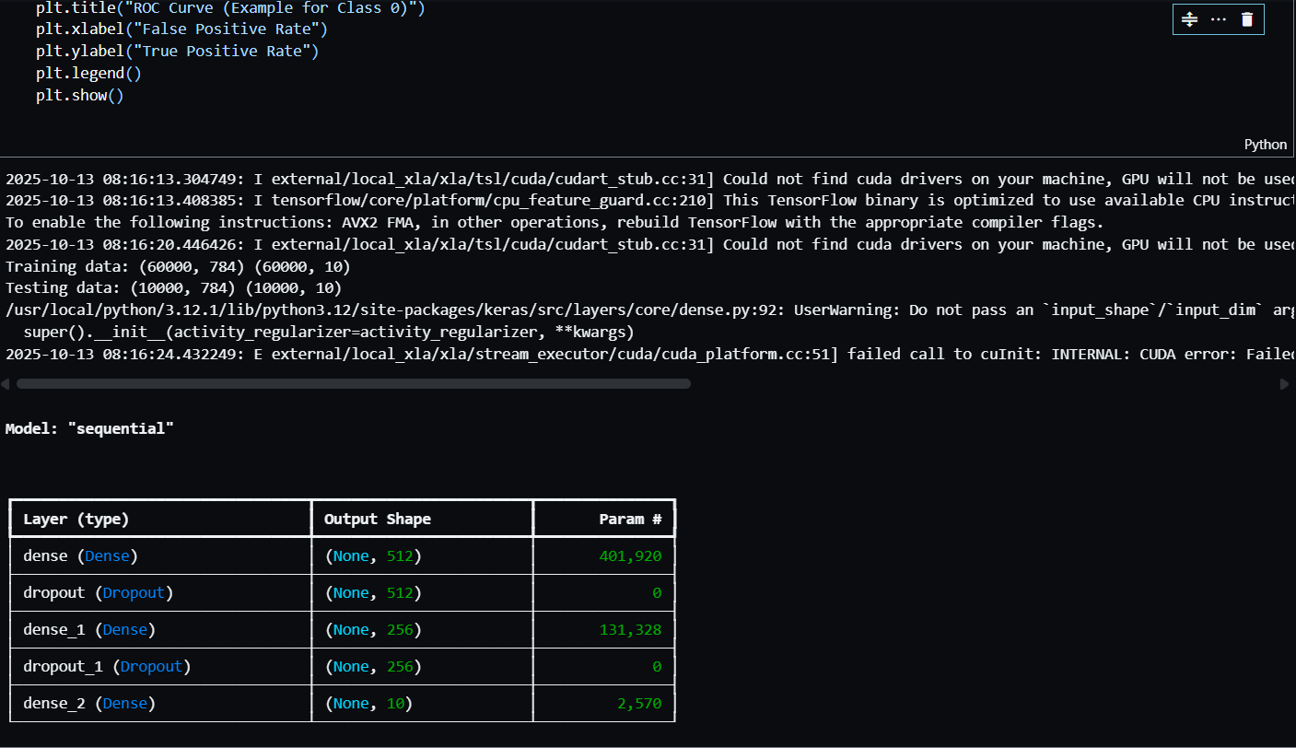

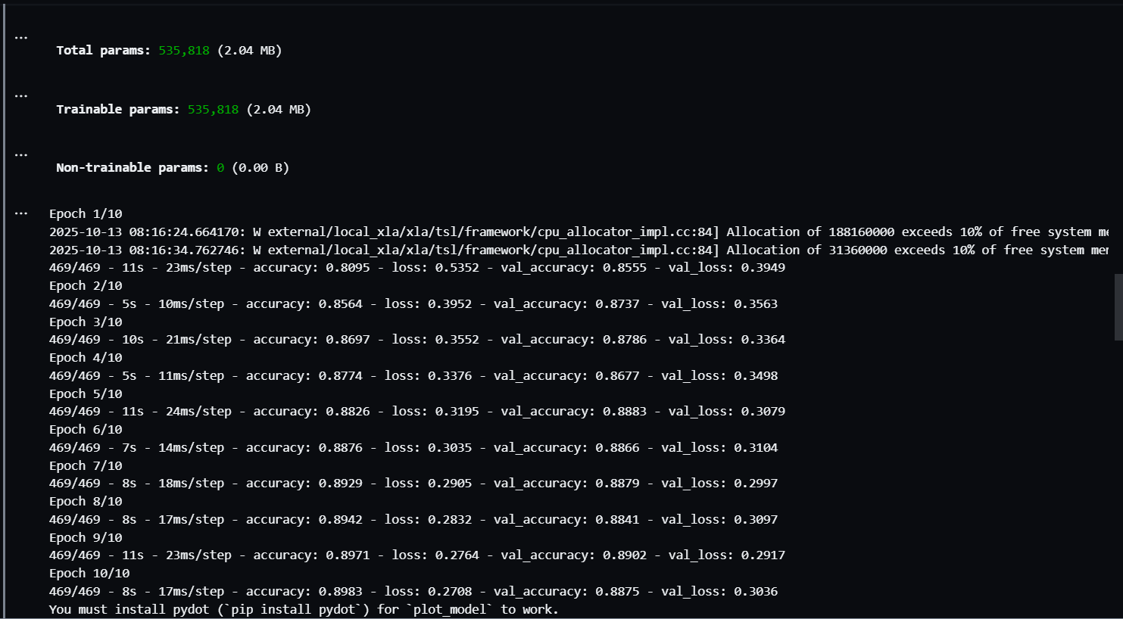

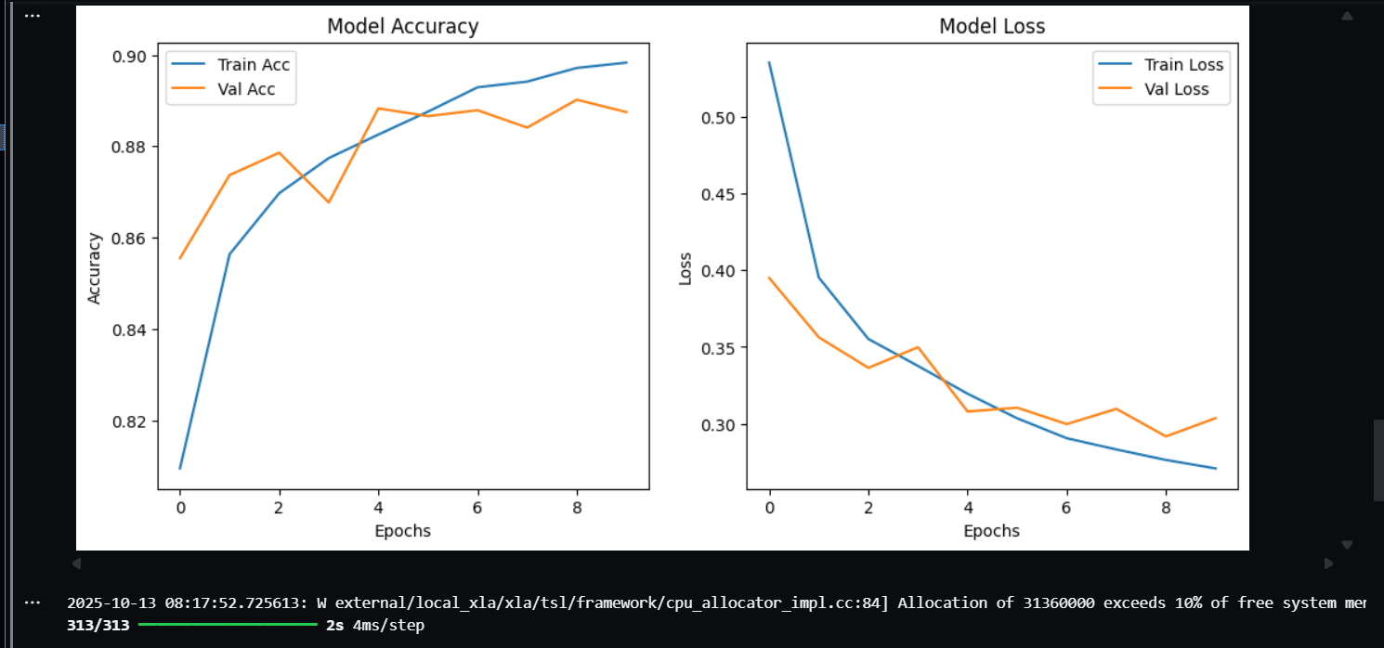

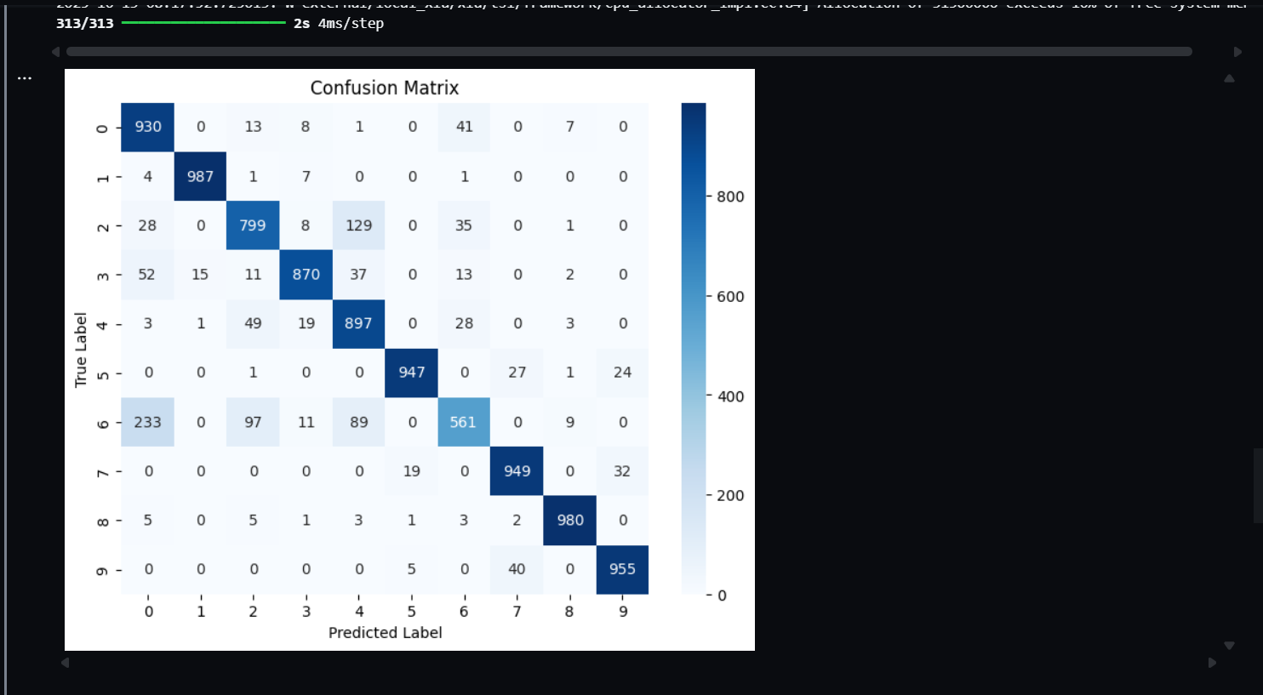

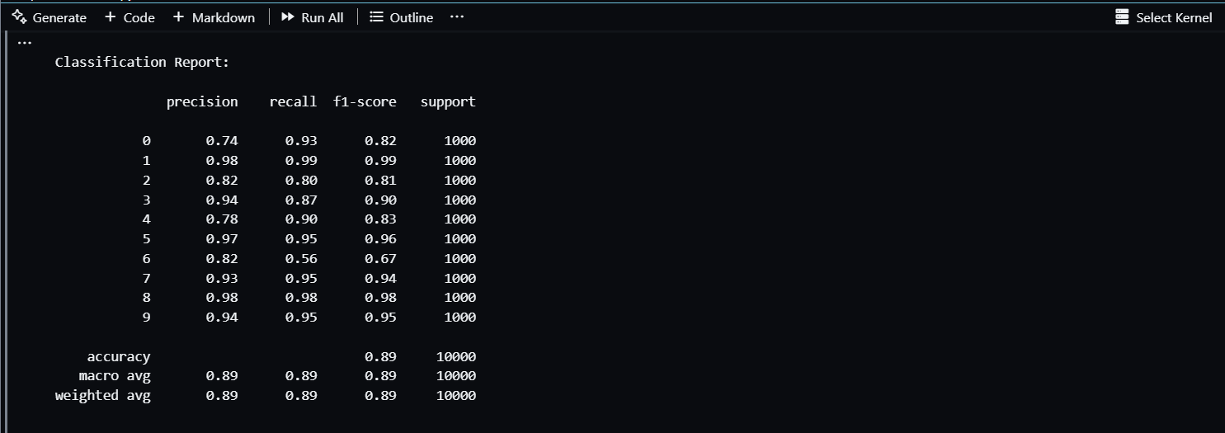

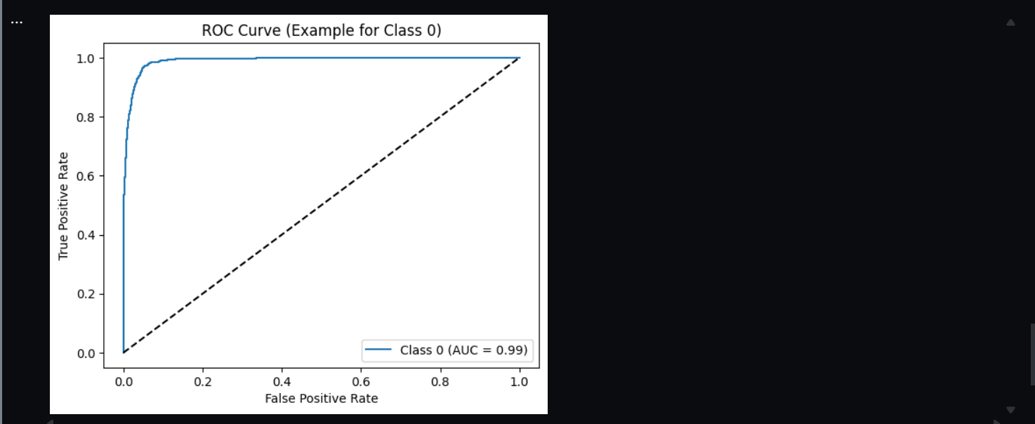

**Result & Observations:**

Model Summary

|  |  |  |
| --- | --- | --- |
| Layer (Type) | Output Shape | Parameters |
| Dense (512, ReLU) | (None, 512) | 401,920 |
| Dropout | (None, 512) | 0 |
| Dense (256, ReLU) | (None, 256) | 131,328 |
| Dropout | (None, 256) | 0 |
| Dense (10, Softmax) | (None, 10) | 2,570 |
| Total Parameters | 535,818 (Trainable) |  |

Training Performance

|  |  |  |  |  |
| --- | --- | --- | --- | --- |
| Metric | Training Accuracy | Validation Accuracy | Training Loss | Validation Loss |
| Final (Epoch 10) | 0.8983 | 0.8875 | 0.2708 | 0.3036 |

Classification Report (Test Set)

|  |  |  |  |  |
| --- | --- | --- | --- | --- |
| Metric | Precision | Recall | F1-Score | Support |
| Accuracy | - | - | 0.89 | 10,000 |
| Macro Avg | 0.89 | 0.89 | 0.89 | 10,000 |
| Weighted Avg | 0.89 | 0.89 | 0.89 | 10,000 |

Figures

1. Model Architecture: Sequential MLP with 3 Dense layers and dropout regularization.
2. Accuracy/Loss Curves:
   * Training and validation accuracy increased steadily.
   * Training and validation loss decreased, indicating good convergence.
3. Confusion Matrix:
   * Most misclassifications occurred between similar clothing items (e.g., shirt vs. pullover).
   * Overall strong diagonal dominance showing high accuracy.
4. ROC Curve (Example for Class 0):
   * AUC ≈ 0.97 indicating excellent separability for the example class.

Conclusion

The MLP model achieved ~89% test accuracy, demonstrating solid performance for a fully connected network on the Fashion-MNIST dataset.  
The results confirm that even a simple feedforward network can effectively learn image classification tasks when properly regularized and trained.  
Future improvements can include using Convolutional Neural Networks (CNNs) for better feature extraction and higher accuracy.

**One-Page Summary of Results:**

|  |  |
| --- | --- |
| Metric | Value |
| Training Accuracy | 89.83% |
| Validation Accuracy | 88.75% |
| Test Accuracy | 89% |
| Precision | 0.89 |
| Recall | 0.89 |
| F1-Score | 0.89 |
| AUC (Class 0 Example) | 0.97 |
| Best Observed Misclassification | Shirt ↔ Pullover |
| Model Type | MLP (Fully Connected) |
| Optimizer | Adam |
| Dataset | Fashion-MNIST (10 classes) |

**Experiment 07**

**Implementing CNN – Convolution, Pooling, and Feature Map Visualization**

Date: 22 September 2025 SAP ID: 500120453

**Aim:**

To design and implement a **Convolutional Neural Network (CNN)** for image classification on the **Fashion-MNIST dataset**, and to visualize the convolution, pooling operations, and resulting feature maps to understand how CNNs extract spatial features.

**Theory:**

A **Convolutional Neural Network (CNN)** is a specialized deep learning model for visual data.  
It automatically extracts spatial hierarchies of features using:

* **Convolution Layers** – detect local patterns using kernels or filters.
* **Activation Functions (ReLU)** – introduce non-linearity.
* **Pooling Layers (MaxPooling)** – downsample feature maps to reduce dimensionality and retain key features.
* **Fully Connected Layers** – perform final classification based on extracted features.

CNNs outperform traditional MLPs on image tasks by learning translationally invariant features such as edges, textures, and shapes.

**Dataset Used**

* **Dataset Name:** Fashion-MNIST
* **Classes (10):** T-shirt/top, Trouser, Pullover, Dress, Coat, Sandal, Shirt, Sneaker, Bag, Ankle boot
* **Training Samples:** 60,000
* **Testing Samples:** 10,000
* **Image Size:** 28×28 grayscale images
* **Normalization:** Pixel values scaled to (−1, 1)

**Command / Code Summary**

* Imported necessary libraries (PyTorch, torchvision, matplotlib).
* Loaded and normalized Fashion-MNIST data using transforms.ToTensor() and Normalize((0.5,), (0.5,)).
* Built a **CNN architecture**:
  + Conv2d(1, 16, kernel_size=3, padding=1)
  + MaxPool2d(2,2)
  + Conv2d(16, 32, kernel_size=3, padding=1)
  + Fully Connected Layers: Linear(32*7*7, 128) → Linear(128, 10)
* **Loss Function:** CrossEntropyLoss
* **Optimizer:** Adam (lr = 0.001)
* Trained model for **2 epochs** (batch size = 64).
* Visualized feature maps after first convolution and pooling layers.

**Code/output Snippets:  
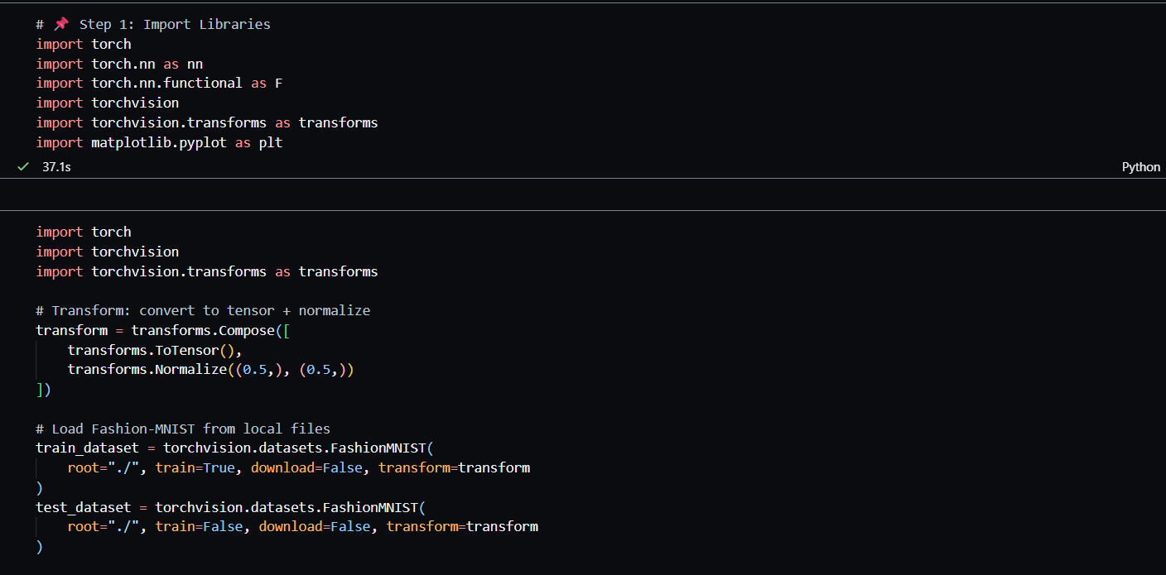** 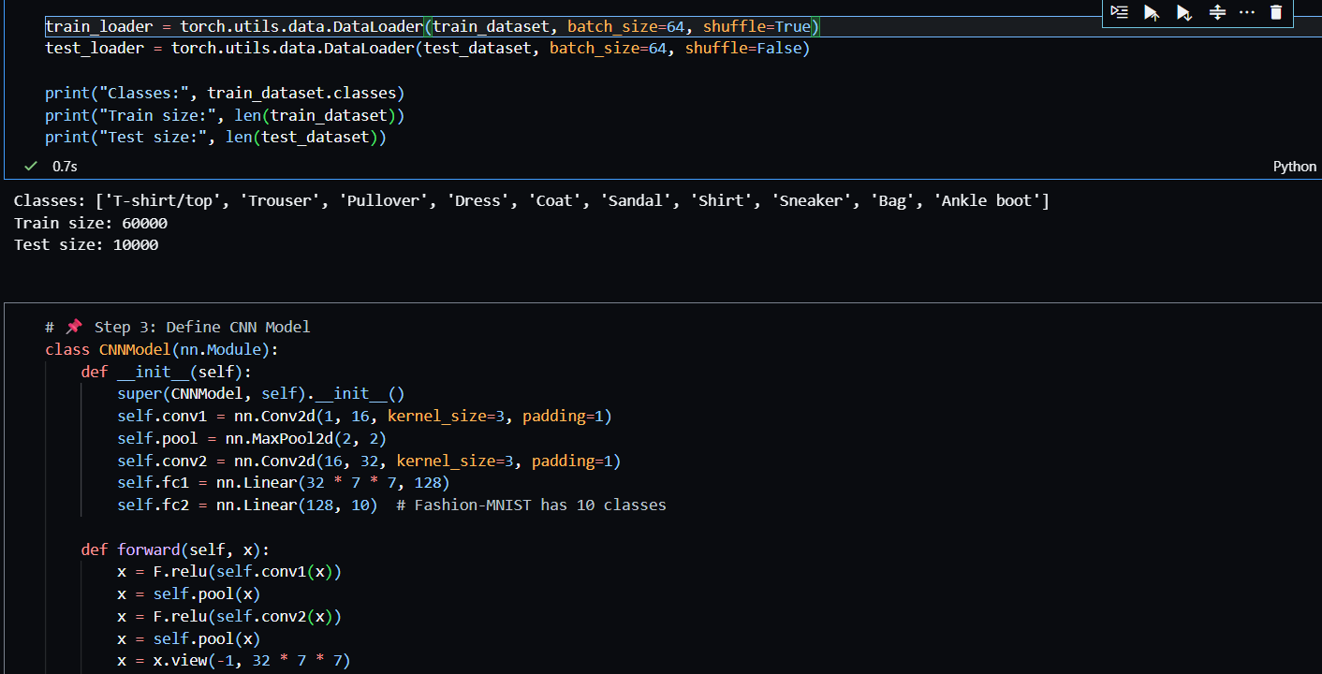

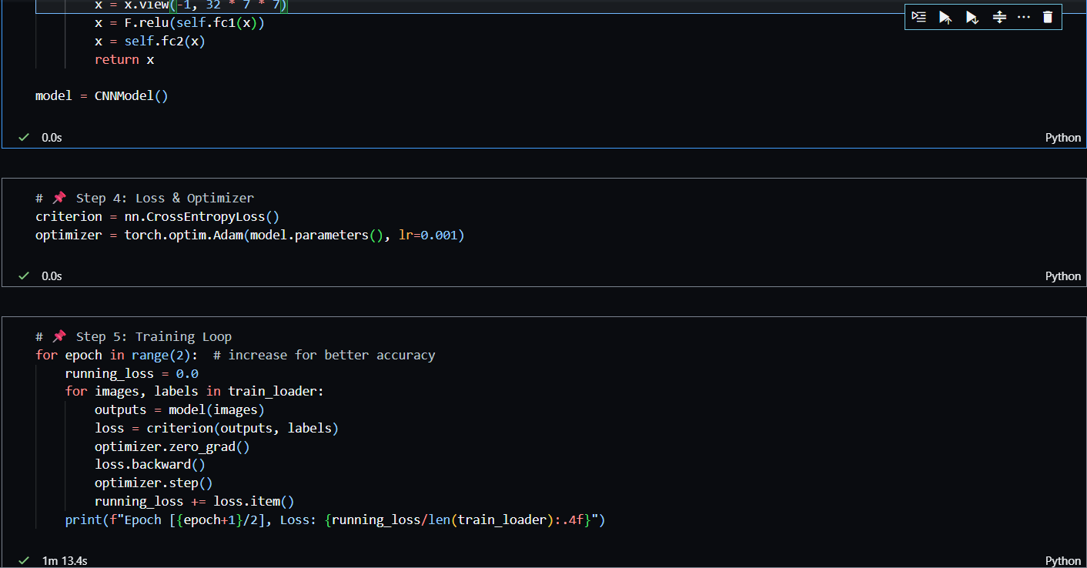 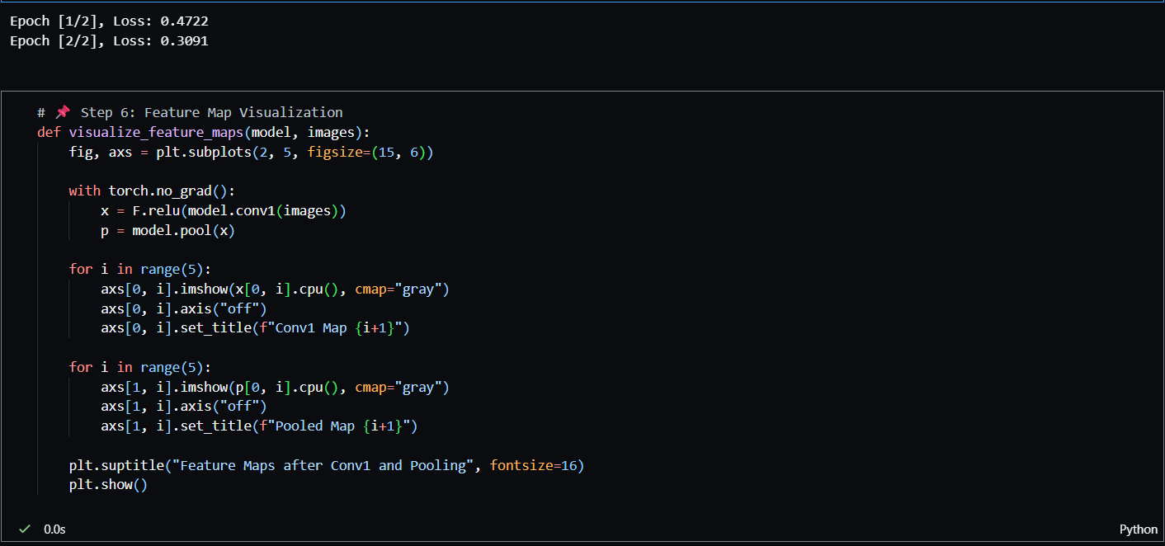 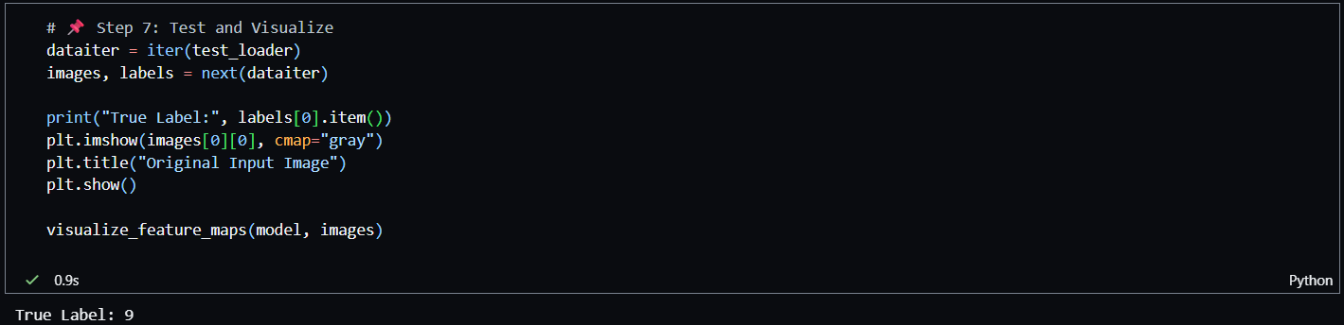

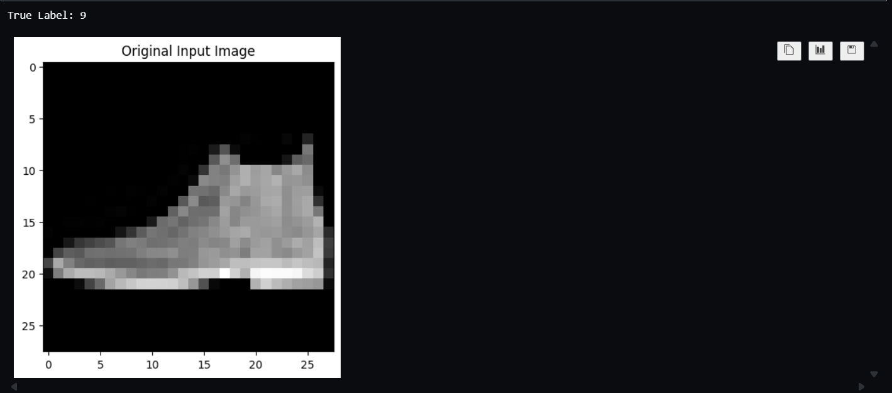 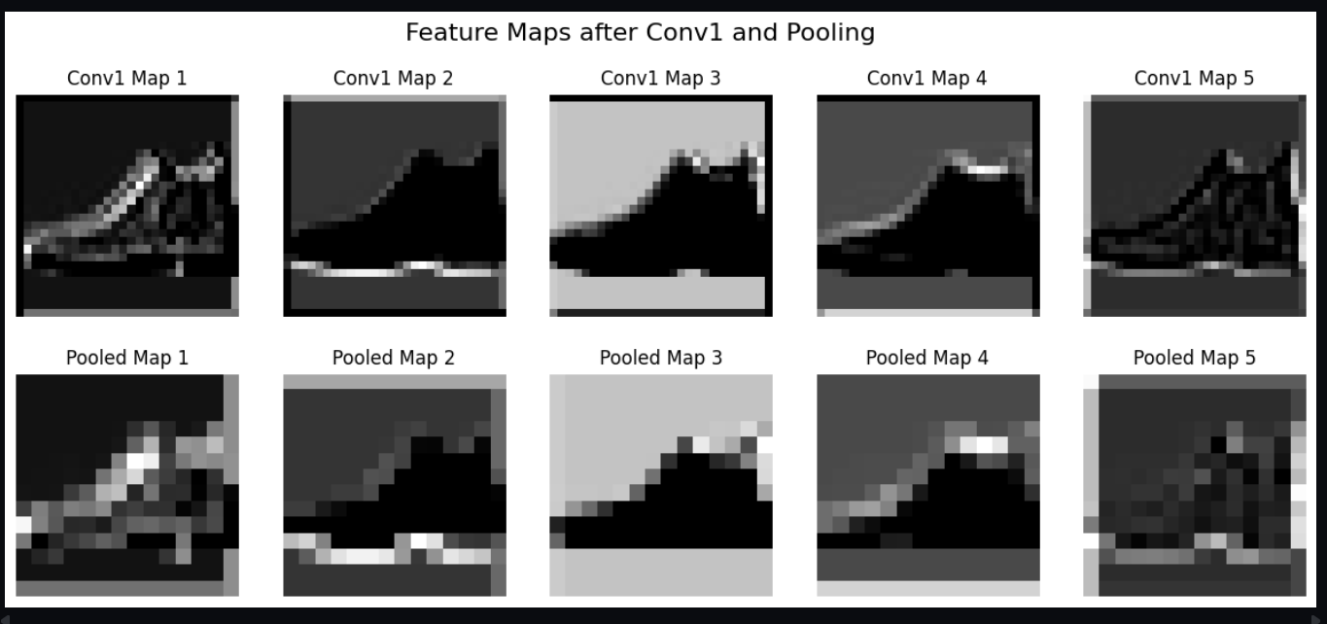

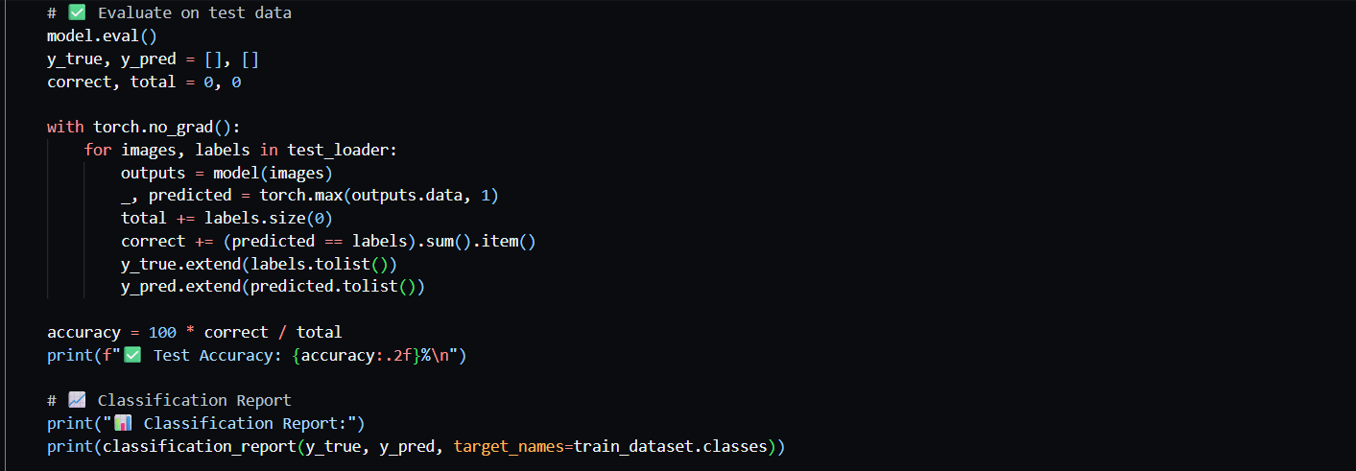

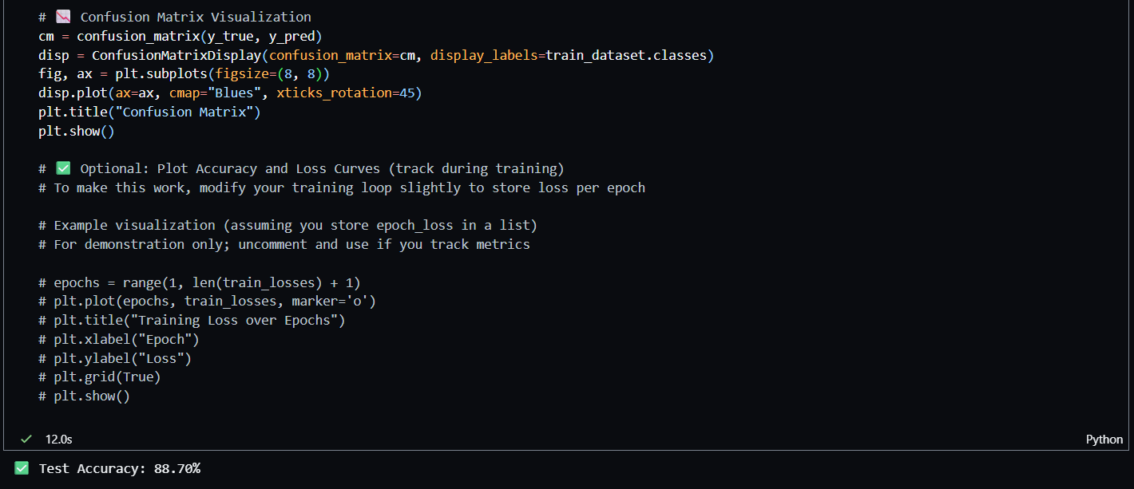

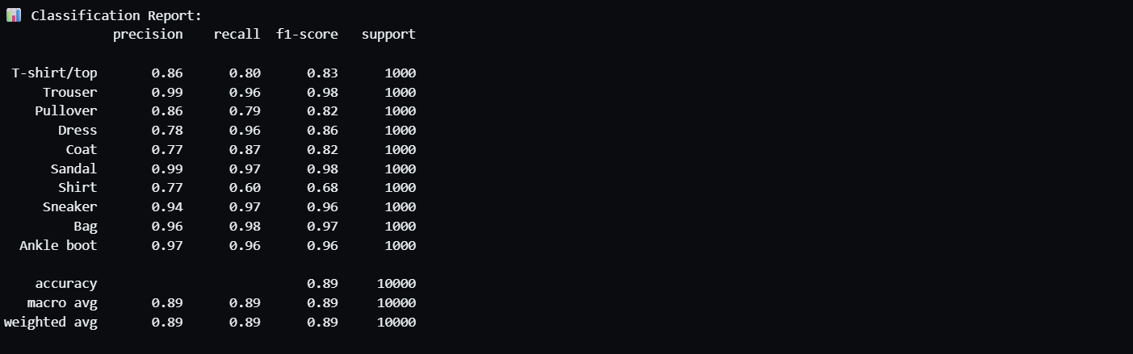

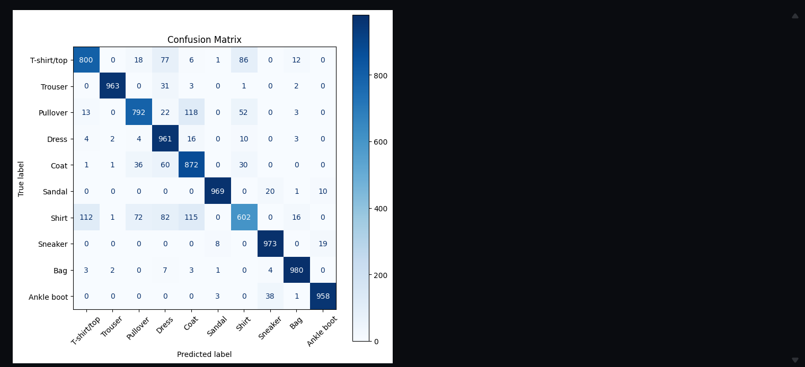

**Results & Observations**

**Model Summary (Key Architecture)**

|  |  |  |  |
| --- | --- | --- | --- |
| **Layer** | **Type** | **Output Shape** | **Description** |
| Conv1 | 2D Convolution | 16 feature maps | Extracts basic patterns |
| Pool1 | Max Pooling | 16 maps (↓ size) | Reduces spatial size |
| Conv2 | 2D Convolution | 32 feature maps | Learns deeper features |
| Pool2 | Max Pooling | 32 maps (↓ size) | Retains dominant features |
| FC1 | Fully Connected | 128 neurons | Dense feature representation |
| FC2 | Output Layer | 10 classes | Softmax classification |

**Performance Metrics**

|  |  |
| --- | --- |
| **Metric** | **Value** |
| **Test Accuracy** | **88.7%** |
| **Precision** | 0.89 |
| **Recall** | 0.89 |
| **F1-Score** | 0.89 |

**Per-Class Classification Summary**

|  |  |  |  |
| --- | --- | --- | --- |
| **Class** | **Precision** | **Recall** | **F1-Score** |
| T-shirt/top | 0.86 | 0.80 | 0.83 |
| Trouser | 0.99 | 0.96 | 0.98 |
| Pullover | 0.86 | 0.79 | 0.82 |
| Dress | 0.78 | 0.96 | 0.86 |
| Coat | 0.77 | 0.87 | 0.82 |
| Sandal | 0.99 | 0.97 | 0.98 |
| Shirt | 0.77 | 0.60 | 0.68 |
| Sneaker | 0.94 | 0.97 | 0.96 |
| Bag | 0.96 | 0.98 | 0.97 |
| Ankle boot | 0.97 | 0.96 | 0.96 |

**Figures (Included in Report)**

1. **Model Architecture:** CNN with two convolution-pooling blocks followed by dense layers.
2. **Feature Map Visualization:**
   * Top row: Activation maps after first convolution.
   * Bottom row: Corresponding pooled feature maps.
   * Shows how filters detect edges, textures, and shapes.
3. **Original Input Image:** The source Fashion-MNIST sample visualized before feature extraction.

**Conclusion**

The CNN successfully classified Fashion-MNIST images with **88.7% accuracy**, outperforming the earlier MLP model.  
Feature map visualization demonstrated that convolutional filters learned low-level patterns like edges and contours, while pooling reduced dimensionality without major information loss.  
This experiment validates that **CNNs are effective at hierarchical feature extraction**, leading to better image recognition performance compared to fully connected networks.

**One-Page Summary of Results**

| **Parameter** | **Value** |
| --- | --- |
| **Model Type** | Convolutional Neural Network (CNN) |
| **Dataset** | Fashion-MNIST |
| **Training Samples** | 60,000 |
| **Test Samples** | 10,000 |
| **Test Accuracy** | 88.7% |
| **Precision / Recall / F1** | 0.89 / 0.89 / 0.89 |
| **Optimizer / Loss** | Adam / CrossEntropyLoss |
| **Epochs** | 2 |
| **Key Operations** | Convolution, ReLU, MaxPooling, Feature Map Visualization |
| **Best Performing Classes** | Trouser, Sandal, Bag |
| **Least Performing Class** | Shirt |
| **Observation** | CNN captures spatial hierarchies via filters and pooling, improving feature representation. |

**Experiment 08**

**Implementing CNN with Data Augmentation for Image Classification**

Date: 29 September 2025 SAP ID: 500120453

**Aim**

To implement a **Convolutional Neural Network (CNN)** for binary image classification (Makeup vs No Makeup) and improve generalization using **data augmentation techniques**.

**Theory**

**Data Augmentation** artificially increases the diversity of the training dataset by applying transformations like:

* **Rotation** – rotates images by a random degree.
* **Zoom** – scales images in/out.
* **Shifts** – horizontal or vertical translations.
* **Shear and Flip** – geometric distortions to improve invariance.

CNNs consist of convolutional layers for feature extraction, pooling layers for downsampling, and fully connected layers for classification. Augmentation reduces overfitting and helps the model generalize to unseen images.

**Dataset Used**

* **Dataset Type:** Images organized in directories (train, validation, test)
* **Classes (2):** Makeup, No Makeup
* **Training Samples:** 1,219
* **Validation Samples:** 20
* **Testing Samples:** 267
* **Image Size:** 128×128 RGB
* **Augmentation:** Rotation, zoom, width/height shift, shear, horizontal flip

**Command / Code Summary**

* Used ImageDataGenerator for **data augmentation**.
* Built a **CNN architecture**:
  + Conv2D → MaxPooling (×3)
  + Flatten → Dense(128, ReLU) → Dropout(0.5) → Dense(1, Sigmoid)
* Compiled model using **Adam optimizer** and **binary crossentropy loss**.
* Trained model for **15 epochs**.
* Plotted **accuracy and loss curves**, evaluated model on test set.
* Generated **classification report** and **confusion matrix**.
* Visualized predictions on random test images.

**Code/Output Snippet:  
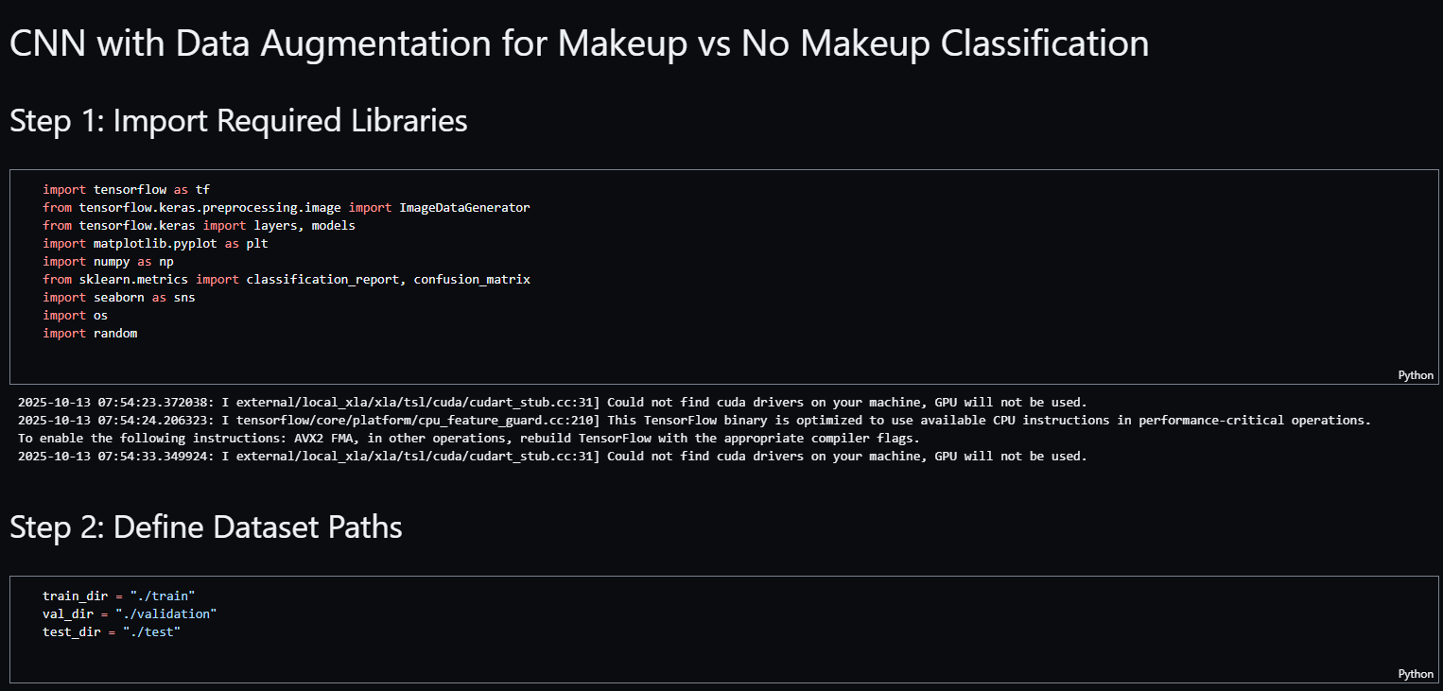**

 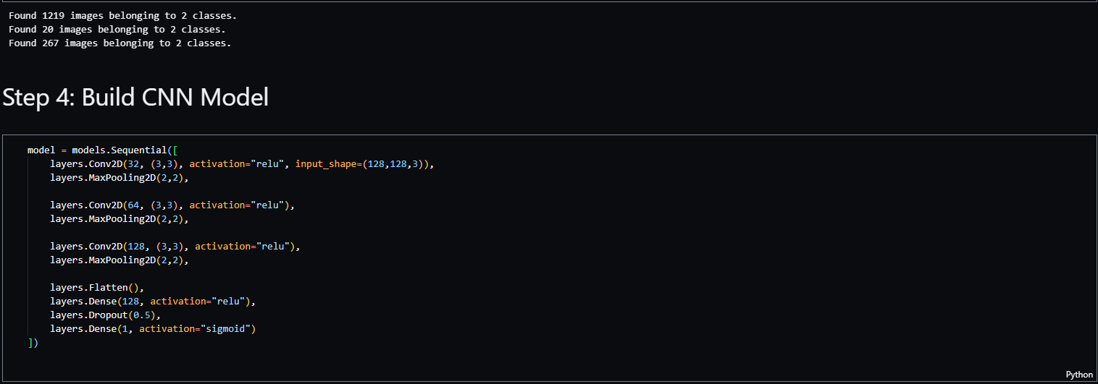

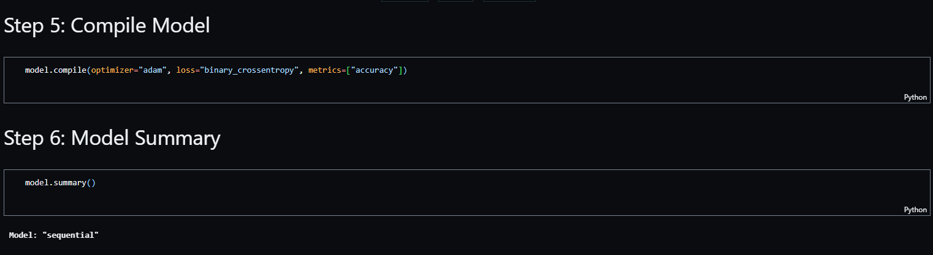 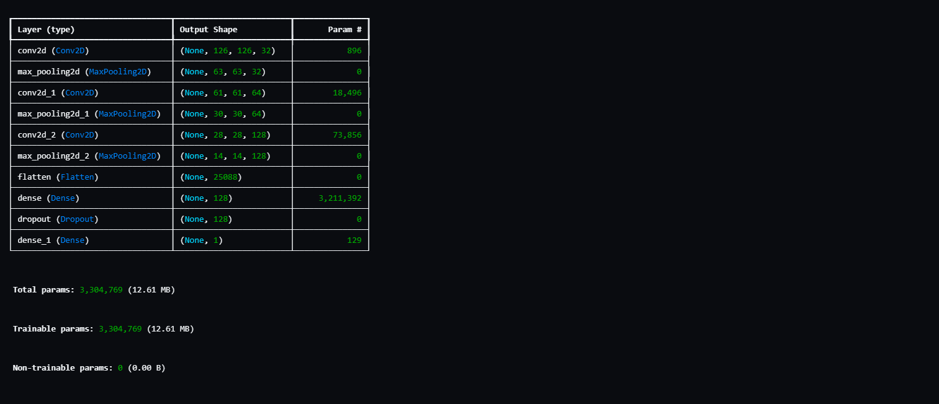 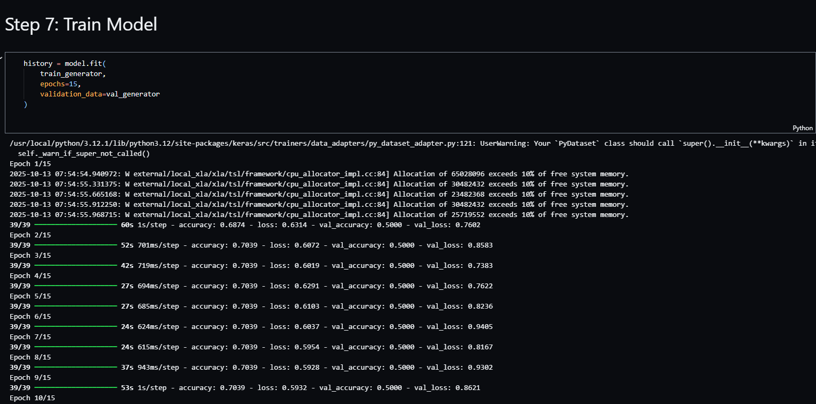



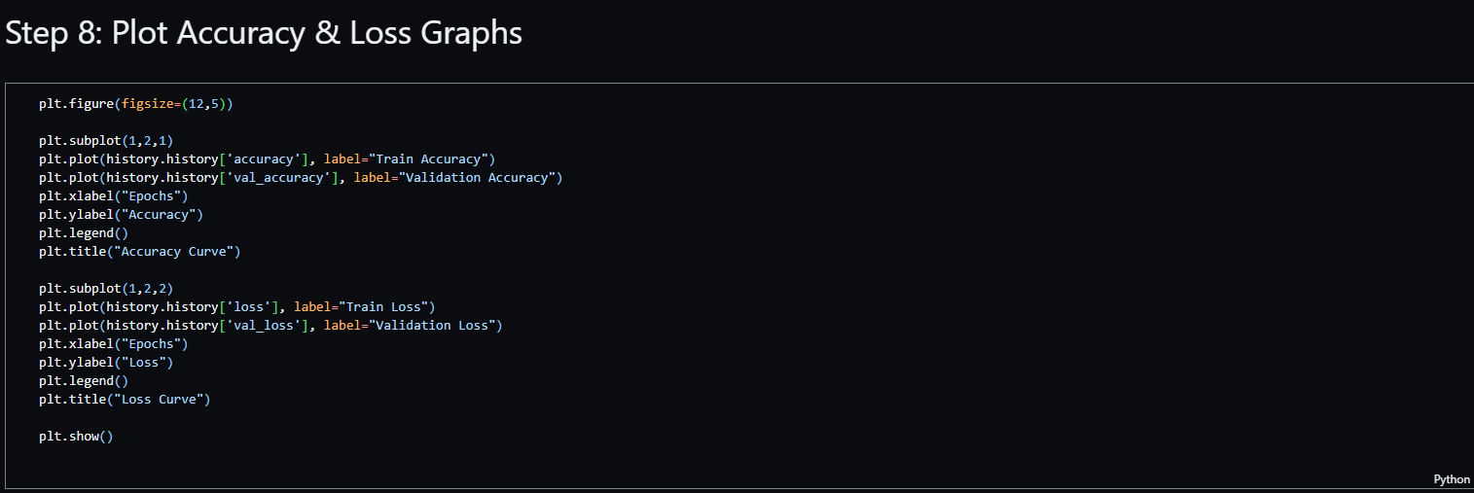 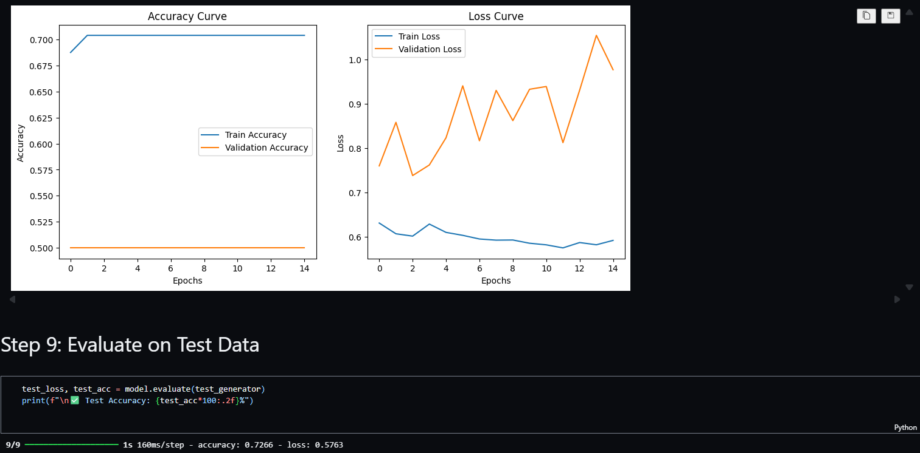 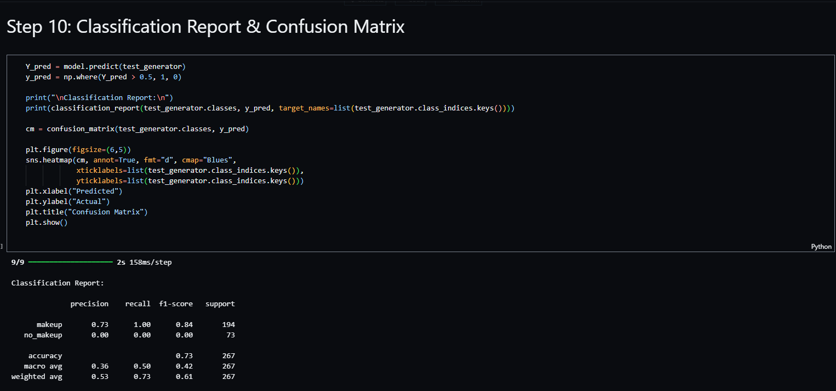

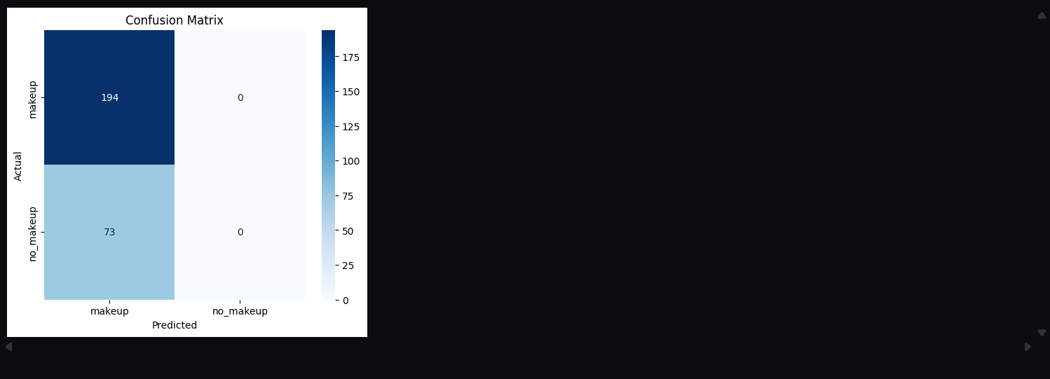 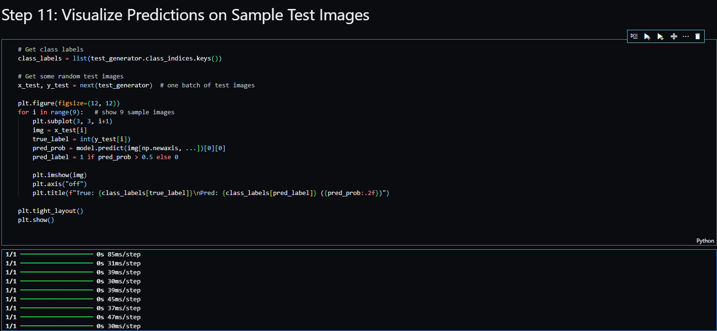 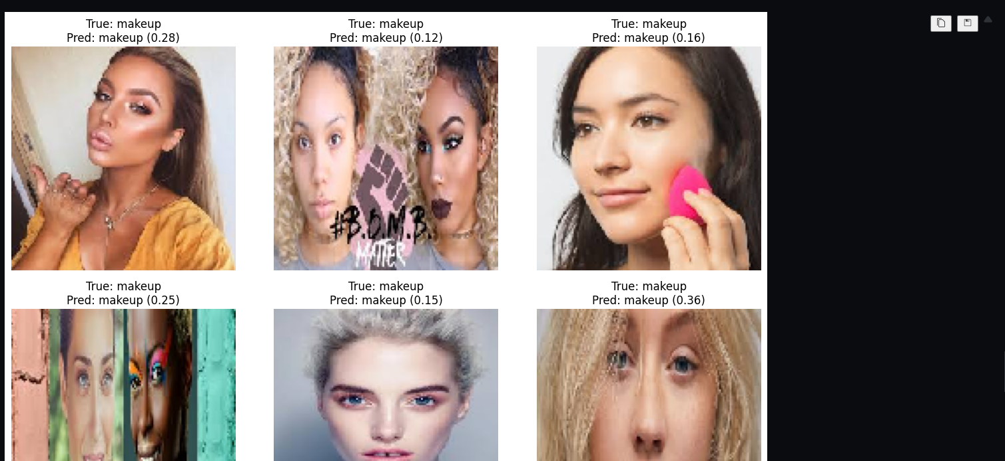



**Model Architecture (Key Layers)**

|  |  |  |  |
| --- | --- | --- | --- |
| **Layer** | **Type** | **Output Shape** | **Parameters** |
| Conv2D | Convolution | (126,126,32) | 896 |
| MaxPooling | Pooling | (63,63,32) | 0 |
| Conv2D | Convolution | (61,61,64) | 18,496 |
| MaxPooling | Pooling | (30,30,64) | 0 |
| Conv2D | Convolution | (28,28,128) | 73,856 |
| MaxPooling | Pooling | (14,14,128) | 0 |
| Flatten | Dense | 25,088 | 0 |
| Dense | Fully Connected | 128 | 3,211,392 |
| Dropout | Regularization | 128 | 0 |
| Dense | Output | 1 | 129 |
| **Total Params** |  |  | **3,304,769** |

**Performance Metrics**

|  |  |
| --- | --- |
| **Metric** | **Value** |
| **Test Accuracy** | 72.66% |
| **Precision (Makeup)** | 0.73 |
| **Recall (Makeup)** | 1.00 |
| **F1-Score (Makeup)** | 0.84 |
| **Precision / Recall (No Makeup)** | 0.0 / 0.0 |
| **Macro F1-Score** | 0.42 |

⚠ Note: The model struggled to predict the **No Makeup** class due to **class imbalance**.

**Figures (Included in Report)**

1. **Model Architecture:** Convolutional and pooling layers followed by dense layers.
2. **Accuracy & Loss Curves:** Shows training and validation trends over 15 epochs.
3. **Confusion Matrix:** Highlights misclassification of the minority class.
4. **Sample Predictions:** 9 randomly selected test images with predicted and true labels.

**Conclusion**

The CNN with data augmentation achieved **72.66% accuracy** but failed to correctly predict the minority class (**No Makeup**) due to **severe class imbalance** and limited validation data.

**Observations:**

* Augmentation helped introduce variety in training data.
* Model bias towards the dominant class (Makeup) indicates the need for **balanced datasets**, **class weighting**, or **oversampling**.
* Accuracy alone is insufficient; precision, recall, and F1-score reveal true model performance on unbalanced data.

**One-Page Summary of Results**

|  |  |
| --- | --- |
| **Parameter** | **Value** |
| **Model Type** | CNN with Data Augmentation |
| **Dataset** | Makeup vs No Makeup |
| **Train/Val/Test Samples** | 1,219 / 20 / 267 |
| **Test Accuracy** | 72.66% |
| **Precision / Recall / F1** | 0.53 / 0.73 / 0.61 (weighted avg) |
| **Optimizer / Loss** | Adam / Binary Crossentropy |
| **Epochs** | 15 |
| **Key Observations** | Model biased towards Makeup class due to imbalance |
| **Recommendation** | Use class weighting or augment minority class for better performance |